Understanding Motion: Activity 5
Graphical Analysis and Comparison of Different Speeds

Name:______________________ Date:____________ Period:_____

Hypothesis: Visualization of multiple “position vs time” data sets on a single graph facilitates the interpretation and comparison of relative velocities.

Guiding Questions:
Introduction: In the previous activity you determined speed from the slope of a position vs time graph. Your experiment was conducted at a constant speed. Often, real-world problems require analysis or comparison of objects moving at multiple different speeds. In this experiment, we will graph data sets which result from different speeds and compare them on the same set of axes.

- How fast do you think you walk normally (in m/s)? ___________
- How fast do you think you jog (in m/s)? _________
- How fast do you think you can run (in m/s)? _________

- If you graphed all 3 situations above on the same graph, which one would have the steepest slope (walk, jog, or run)? __________
Goals:
- Demonstrate the effectiveness of comparing data sets on a single graph. In this case, the rate of change (a very important concept in physics) will be visualized by observing the slope of linear fits to multiple data sets.
- Reinforce the concepts of distance and speed from activities 1-4

Instructions:
You may have noticed that “Location (GPS)” module in the Phyphox app performs calculations to determine distance traveled and speed. The app provides graphs and exports the results of the calculations. We will take advantage of this feature in this experiment (now that you understand how the calculations are done).

- Collecting your data: Choose a ~100-m stretch of straight sidewalk or field with little elevation change. Collect GPS data while you walk, jog, and run this route.
  - Start the GPS data collection and collect data for ~20 s while standing still before starting to walk your route at a constant pace. After reaching the end of your route, collect approximately 10 seconds of data while standing still before stopping the experiment. Export the data as “Walk data”.
  - Using the same procedure, collect a new data set as you jog at a constant pace back to your starting point. Export this data as “Jog data”.
  - Finally, collect data as you run a constant pace the length of your route. Export your data as “Run data”.

- Create a new Sheets/Excel file called “Speed Comparison”. In A1 put the label “Time (s)”, in B1 put the label “Walking Data (m)”, in C1 put the label “Jogging Data (m)”, and in D1 put the label “Running Data (m)”.
- Before we graph our data, we need to convert the distance from km to m. In each of your Excel files with your Raw Data, create a new column that simply takes the data from the “distance (km)” column and multiplies it by 1000 and label it “Distance (m)”.

- You now need to look at your data and see if it is necessary to make any corrections to the distance values. Upon starting the GPS measurement, it often takes a short time to refine the position based on the satellite signals. Inaccuracies in the initial measurements of position can result in calculating significant changes in displacement that do not represent real movement. The figure below shows the calculated distance traveled while standing still. Eventually the position will stabilize as shown below. The actual distance traveled can be determined by subtracting the value or distance traveled at the time of stabilization, from all the values in the distance travel column. Create a new column for this corrected distance and label it “Actual Distance (m)”. This actual distance should now be zero at the time prior to starting your real movement. You will need to do this for all three of your raw data files for walking/jogging/running.
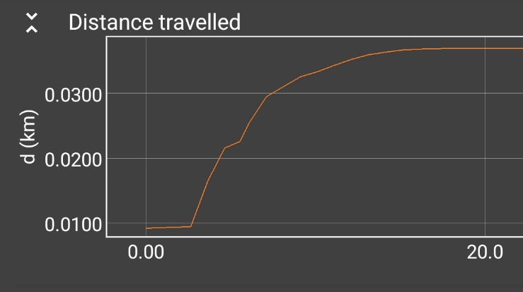
- Now it’s time to move your Actual Distance data from the Walk, Jog and Run spreadsheets into the “Speed Comparison” spreadsheet. For each of the data sets, copy and paste (values only) the “Distance (m)” column into your “Speed Comparison” file in the appropriate columns. Since you are only interested in the slope of the data when you were moving at constant velocity, you should cut and paste the data that represents your motion while moving at a (near) constant speed (as you did in part 3 of Activity 4).
- The last thing to do is enter values into the “Time (s)” column. As the GPS collects data every second, can enter values of 0, 1, 2, … etc. yourself or cut and paste the time values from one of your raw data spreadsheets. Your spreadsheet should now look something like this:
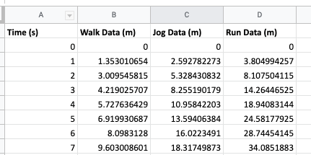
- Now it is time to create a chart. Select all of your data and insert an x-y scatter chart. You should see all three data sets. If it is missing anything (Titles, Labels, etc.) be sure to add it.
- Finally, add trendlines to each data set and show the equation. Insert your graph below.

Analysis and Discussion:

- Which type of motion had the shallowest slope in your graph?
- Which type of motion had the steepest slope in your graph?
- Using the answers to the last two questions, what can you say happens to the slope of a Distance vs Time graph as the speed gets faster?
- List your speeds for your various types of motion here:
Walking _______ m/s
Jogging _______ m/s
Running_______ m/s
How do these compare to what you predicted in the beginning?
- What type of motion would correspond to a graph with zero slope?
- Would it be possible to have motion that would result in a vertical line? If so, give an example. If not, why not?

Extension Questions:
- How you think the data in the following graph was collected? Explain your reasoning.

