Understanding Motion: Activity 4
Determining Velocity (a vector) and Speed (a scalar)

Name:______________________ Date:____________ Period:_____

Hypothesis: Velocity and speed of a person, can be accurately determined by using a GPS sensor to measure position as a function of time.

Guiding Questions:
Introduction: GPS navigation systems are most well-known for their ability to give people directions to any destination, but navigation applications also determine the speed at which you are traveling.

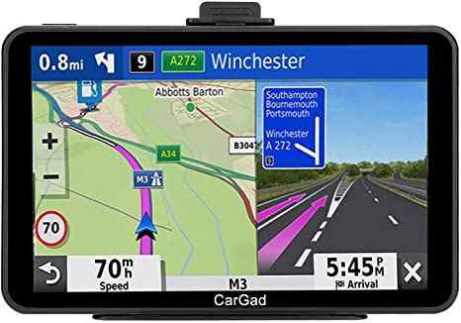

- How do you think a GPS navigation application determines speed?

- Units often tell us what we need to measure in an experiment. What are the units of velocity in SI units?

- Describe the difference between speed and velocity.

Goal:
- Develop an understanding of the difference between vectors and scalers by observing motion in one dimension and creating graphs of velocity and speed.
- Demonstrate the determination of “instantaneous” velocity by measuring the change in position between sequential GPS measurements.
- Explore the use of graphical analysis to determination average velocity. This will introduce the skill of creating a best fit line to analyze data in a spreadsheet.

Instructions:
- Using the spreadsheet containing the data from Activity 1-3, create graphs of velocity vs time and speed vs time.
  - Create two new columns for velocity and speed in columns H and I.
  - Place zeros in the cells H2 and I2 to indicate the initial velocity and speed are zero.
  - The “instantaneous” velocity can be calculated using the change in displacement divided by the change in time. This can be done by typing “=(F3-F2)/(A3-A2)” in H3 and then propagating this for the entire column.
  - The “instantaneous” speed and “instantaneous” velocity have the same magnitude but may have different signs. You can calculate the speed by taking the absolute value of the velocity. This can be done by typing “=abs(H3)” in I3 and then propagating this for the entire column. Your spreadsheet should look something like this:
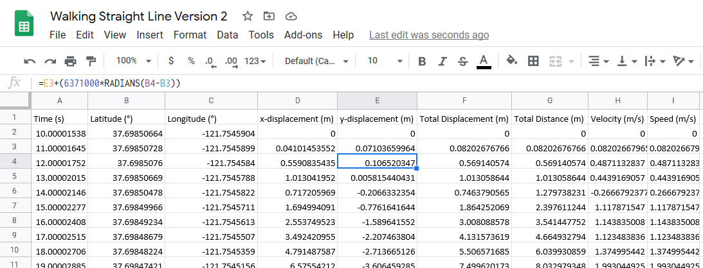

  - Graph velocity vs time in your spreadsheet.
  - Graph speed vs time in your spreadsheet.
  - Sketch (or paste) your graphs below and indicate the estimated average velocity and speed on your graphs for the time you were walking from location A to location B and from location B to location A.

Average Velocity A→B = _________ Average Velocity A←B = __________

Average Speed A→B = _________ Average Speed A←B = __________
- Calculate the velocity from the slope of a displacement vs time graph by visual inspection of values on your graph.
  - From your spreadsheet, select the displacement vs time graph. Make sure the scales are set to assure the data fills most of the space on the graph. Add grid lines to assist you in reading precise values from the graph.
  - Estimate the average velocity when moving from location A to location B by determining the slope of the line while you were moving at constant velocity between the two locations.
  - Using the same method, estimate the velocity when moving from location B to location A. (note the sign of the slope)
  - Show your graph of displacement vs time and your calculation of the slope below.

Average Velocity A→B = _________ Average Velocity A←B = __________
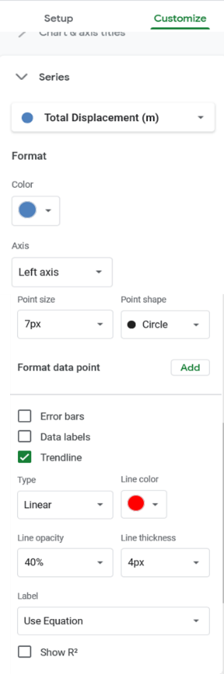
- Calculate the velocity from the slope of a displacement vs time graph using a best fit line to the data in a spreadsheet. To do this, you will need to create a new graph that only includes the data for the time you are moving between two locations. Since you are only interested in the slope during the time you are moving at a constant velocity, you can skip a few data points at the beginning of your movement and a few data points just prior to stopping. You will be generating a graph that looks like the graph shown below.

  - Select the data from the time interval for movement from location A to B. Copy the time and displacement data into two new columns.

  - Graph displacement vs time. If you were walking at constant velocity, your data should appear to follow a straight line.

  - Now choose to add a trendline and display it on your graph. The figure to the right shows how to choose a linear trendline and display the equation for the fit in Google Sheets.
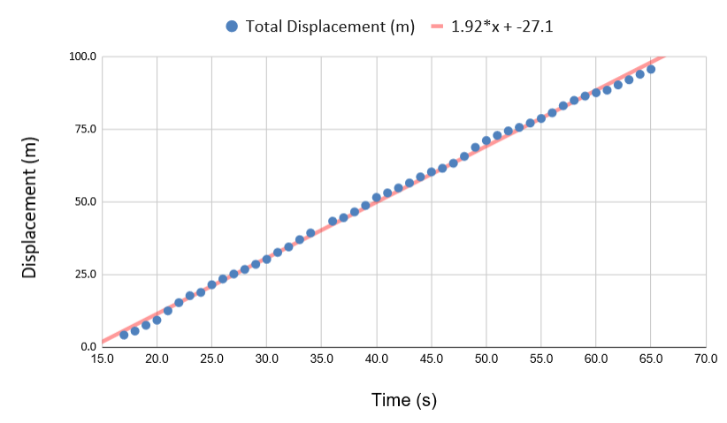

  - Repeat steps a-c for movement from location B to A.
  - Show one of your graphs below.

Average Velocity A→B = _________ Average Velocity A←B = __________
Analysis and Discussion:

- Compare/contrast the velocity and speed graphs from Part 1. Use the terms vectors and scalars in your comparison.

- Explain why the values for velocity and speed have such large variations (noise) when you analyzed sequential data points in Part 1.

- Compare the slope you determined in part 2 when you traveled from A→B and from B→ A. What changed?

- Compare the velocities from Parts 1, 2 and 3. Which value of velocity do you think is the most accurate? Explain your answer.

Extension Question:
- It would be difficult to travel to our favorite locations if we only traveled in straight lines. Can we apply what we have learned to make measurements of speed as we move along curved paths? Explain how you might do this analysis.

