Understanding Motion: Activity 3
Determining Displacement (a vector) and Distance (a scalar)

Name:______________________ Date:____________ Period:_____

Hypothesis: Displacement and distance, over short distances, can be accurately determined from the position (latitude, longitude) vs time data measured by a GPS sensor. Position accuracy of ~1 m can be determined from the information encoded in electromagnetic waves from multiple satellites that are over 20,000,000 m away from the sensor in your phones.

Guiding Questions:
Introduction: If you want to travel from Chicago (USA) to Rome (Italy), which are at both at 41° latitude, you can get there by traveling east or west. However, if you travel west, you will travel a much longer distance than if you travel east before reaching Rome. Vectors, like displacement and velocity, describe a direction as well as an amount. Scalars, like distance and speed, only describe an amount. In physics, we will frequently use vectors and scalers to describe physical processes. It is important to recognize when direction is an important part of describing a physical quantity.

- Consider the walk you took in activity 1 (from A to B back to A). Which quantity would best be used to describe how far you walked in terms of the exercise you got?
Distance (scalar) Displacement (vector)
- Which quantity would best be used to describe where you ended up when you were all done?
Distance (scalar) Displacement (vector)
Goal:
- Develop skills in using formulas in spreadsheets while calculating displacement and distance from position data (latitude and longitude).
- Demonstrate the difference between vectors and scalars using graphs of displacement and distance.
- Develop an understanding of how GPS data is collected and used by devices we depend on almost every day.

Warmup/Preparation Activity:
- The following video provides a simplified description of how global navigation satellite systems (GNSS) work as well as provides an understanding of the global competition for these critically important systems. https://www.youtube.com/watch?v=4JCQi9V7oCk

Instructions:
- You will be using the spreadsheet containing the data from Activity 1. If you did not save your data, repeat Activity 1 (steps 1a-1h). The distance between two points can be calculated using the equations below (note: these equations are accurate for distances which are small relative to the radius of the Earth). Estimate the average values for latitude and longitude when you were at stationary at positions A and B. Using those average values of latitude and longitude, calculate the displacement using a calculator or the template worksheet provide separately.

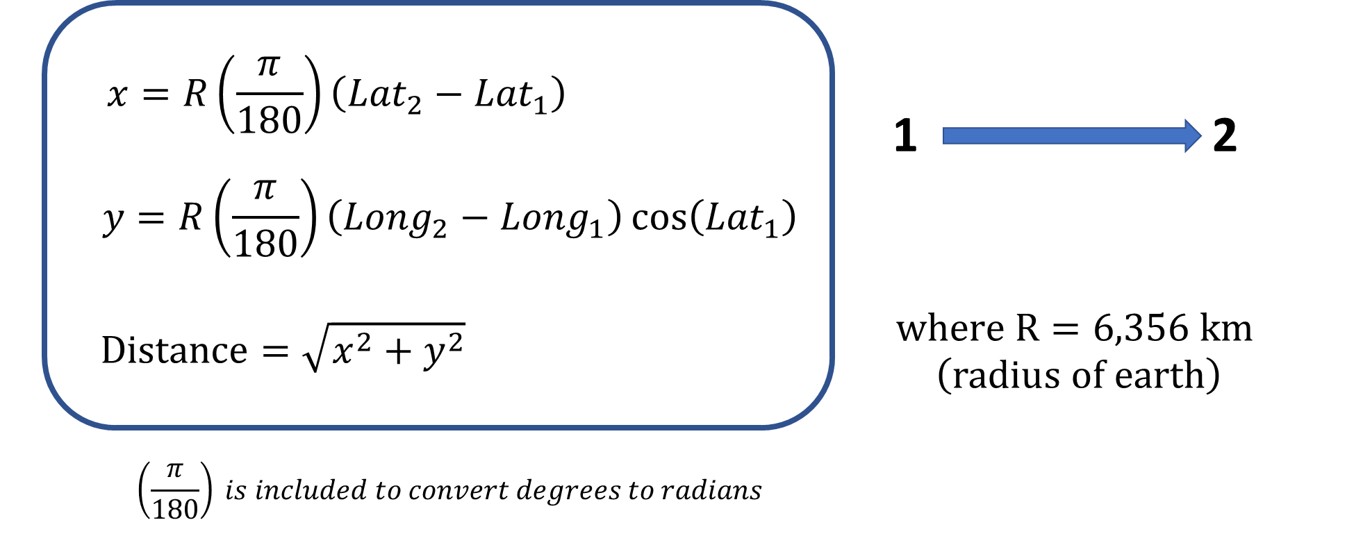
  - Compare the distance you calculated from the GPS data to the estimated distance you walked in the experiment. Does your calculated value seem reasonable based on your estimate? If not, check your calculation.

  - One way to determine the precision of your GPS data would be to calculate the displacement using the average values for location A at the beginning and the end of your walk. Perform this calculation. What was the approximate precision of your measurement?

- Calculate the displacement and distance traveled at each time during your walk. (This is definitely a task for a spreadsheet as we do not want to do the calculation by hand for each point.)
- In your spreadsheet, create a new sheet and call it “Distance/Displacement Data”.
- Copy the “Time (s)”, “Latitude (°)”, and “Longitude (°)” columns from your raw data and paste them into this new sheet so that they are in columns A, B, and C, respectively:
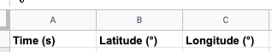

- Before proceeding with your analysis, you need to make a small adjustment to the data that will be analyzed. Often, the first few seconds of your position measurement are not accurate because it takes several seconds to establish your position from the satellite signals. You will get the best results if you delete the first 10 seconds of data. (Select the rows as shown below and then choose edit/delete rows.)
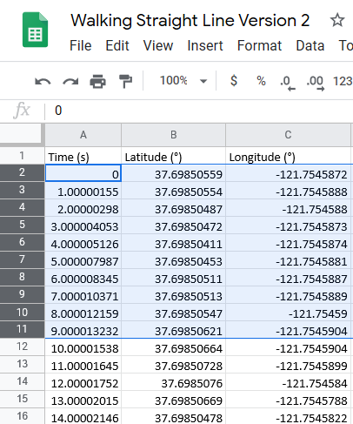

- In the next few steps, you will use a stepwise procedure to calculate the displacement along latitude, longitude and the total displacement using the equations from part 1. Create a heading in cell D1 labeled “x-displacement (m)” and put a ‘0’ (zero) in D2. Then, create a heading in cell E1 labeled “y-displacement (m)” and put a ‘0’ (zero) in E2. The zeros in the first cells, define a reference position for our calculation where we define this position as our origin.
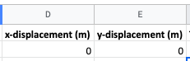
- You are now ready to calculate the displacement for each position (latitude, longitude). Since you walked in a specific direction, this is a vector. Following the same method as in part 1, you can calculate the displacement for each point using the first point as the origin. In cell D3, type the following (without the quotations) “=D2+6371000*RADIANS(C3-C2)*COS(RADIANS(B3))”. Next, you will hover your cursor over the tiny box in the bottom right corner of D3 (cell D3 must be selected to see it), and click and drag it all the way down to the last line of your data:
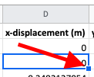
This copies the formula into all of the cells that you highlighted and it appropriately references the correct relative cells for completing the calculations. (Highlight the individual cells to observe for yourself how the formulas and relative values were propogated.)
- Calculate the y-displacement. In cell E3, type the following (without quotations) “=E2+(6371000*RADIANS(B3-B2))” and then drag that formula down to the bottom of your data.
- Use the x and y displacements to calculate the total displacement and distance. Create a heading in cell F1 labeled “Total Displacement (m)” and put a ‘0’ (zero) in F2. Then create a heading in cell G1 labeled “Total Distance (m)” and put a ‘0’ (zero) in G2.
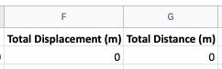
- The formula for this part is much simpler. If you’ve learned about right triangles, you know about the pythagorean theorem. The total displacement is determined by adding vectors together using the last equation in the box for part 1. In cell F3, type the following (without quotations) “=SQRT(D3^2+E3^2)” and drag that formula all the way down to the bottom of your data.
- You should notice that your displacement should go back to zero (or within a few meters), as you returned to your original position. Displacement simply tells you how far away you ended up from your original position. If the displacement is larger than a few meters, check the following to see if you made an error:
  - Double check all of the formulas.
  - Make sure the formulas have updated with the appropriate cell references.
  - Make sure you are including all of your data.
  - If none of these fixes the issue, re-do the first activity and be careful to only walk in one direction and then back to your starting place.
- Now graph Total Displacement vs Time by selecting both columns and inserting a chart. Sketch or paste what you see below:

- Your displacement graph represents where you were at each point in time, but it does not provide information on how far you walked. The total distance you traveled can be calculated by summing up the absolute value of the distance traveled during each time interval. In cell G3, type the following (without quotations) “=G2+ABS(F3-F2)” and drag that formula all the way down.
  - What is the final value for your distance? ________ m
  - This value should be about 2x your maximum displacement. Is it? ______ If not, follow the troubleshooting steps in part (h).
- Finally, create a chart based on the distance data you just calculated and sketch or paste what you see below:

Label the different parts of the graph for when you were moving and when you were standing still.

Extension Questions:
- If you had access to the position data for everyone’s cell phone, how might you use that information to inform policies and actions during a pandemic?

- If you took your cell phone hiking and there was no cellular signal available, could you still use your phone to find your position using GPS? Explain.

