Science of Collisions: Activity 2
Exploring the Effects of Physical Properties in Inelastic Collisions

Name:______________________ Date:____________ Period:_____

Hypothesis: 1) The mechanical energy retained following a collision depends on the physical properties of the colliding objects. 2) The measurement of sound waves that result from collisions can increase the precision of measuring collision times and hence improve the ability to investigate the details of collisional processes more carefully.

Guiding Questions:
Introduction: The differences in how different types of balls bounce is very important in sports. We expect tennis balls, golf balls, baseballs, and basketballs to all behave differently when they collide with different surfaces such as rackets, clubs, bats, or gym floors.
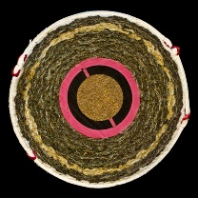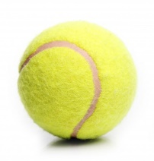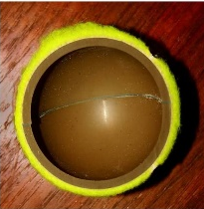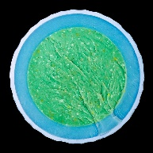

- What properties do you think might be important in making collisions more elastic or inelastic?

- What makes a collision elastic or inelastic is not always intuitive from our everyday observations. Consider a steel ball bouncing on a steel plate. Estimate how you might expect the collision to behave on the scale below and then watch the video in the link. Discuss the observation and provide a possible explanation. https://www.youtube.com/watch?v=v6zB-ME6N-U
Very Elastic ----------------------------------------------------------------------------------Very Inelastic

Goals:
- Investigate the physical properties that determine what makes collisions more elastic or inelastic. Explore how molecular level material properties translate into macroscopic properties.
- Develop scientific and engineering practices by exploring the use of sound waves to precisely measure the time of a collision and comparing the method to alternative approaches.
- Apply the understanding of inelastic collisions to solving real-world problems.
Instructions:
Determine the energy retained by a bouncing ball from a measurement of the time between collisions using sound waves to time each collision.

  - Investigate the sound waves created by a collision. Use the Audioscope module in the phyphox application to measure the rapidly fluctuating air pressure associated with a sound wave.
    - Open the audioscope module and set the time scale to 500 ms (the longest possible)
    - Using the play/pause function, capture a “sound wave” associated with one collision of the ball with the surface. You can start data collection, drop the ball and while it is bouncing you can pause data collection. It is likely that a sound wave from one of the bounces will be captured by the microphone. You may have to repeat this several times until you get the timing correct and capture the sound wave from a bounce.
    - Include screenshot of the sound wave amplitude as a function of time for the full scale (500 ms) and for an expanded view of the beginning of the sound wave amplitude (5 ms of data).

  - Explore the use of the Acoustic Stopwatch module in the phyphox application. This application starts and stops a timer when it measures an increase or decrease in the pressure associated with a sound wave.
    - Observe how changing the Threshold and Minimum Delay setting is used to control trigger the starting/stopping of the timer based on the amplitude of the noise. The delay is used to make sure that a signal “noise” does not start and stop the timer.
    - Investigate the use of Sequence, Parallel and Many modes of operation.

  - Using the Acoustic Stopwatch, measure the collision times for the experimental design used in for “Science of Collisions: Activity 1”. Use the analysis method developed in Activity 1 to calculate the average percent energy retained from your collision time data.

  - Phyphox has a module specifically designed to use the principles of the acoustic stopwatch to determine the times between bounces and then use that data to calculate the height and retained energy for each bounce. Use the (In)elastic Collision module to analyze the same experiment from above and compare the results from the three different methods.

Method for Measuring Collision Times | Average % Energy Retained
Accelerometer – Vibration (from Activity 1)
Microphone – Sound Wave (Acoustic Stopwatch)
Microphone – Sound Wave (Inelastic Collision Module)

  - The automated Inelastic Collison Module simplifies the determination of average percent energy retained. Using this automated tool, measure the average percent energy retained for at least 5 different ball/surface combinations. You may need to adjust the Threshold and Minimum Delay in Settings to achieve reproducible results (i.e., each individual collision should provide similar values for % energy retained). Provide screen shots of your data and summarize your data in a table. (example shown)
Ball / Surface | Average % Energy Retained
Tennis Ball / Wood Desk | 64.0

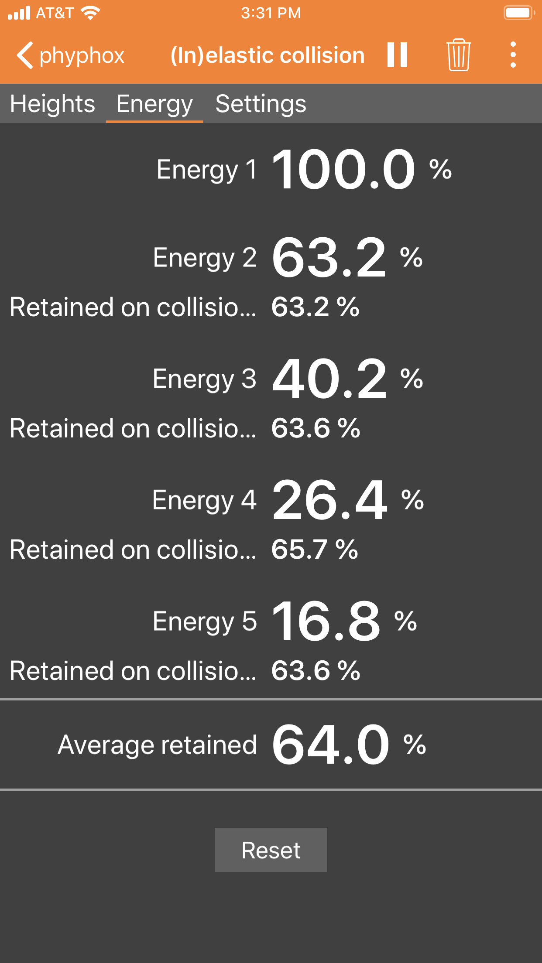

Analysis and Discussion:

- Based on your measurement of the sound wave using the audioscope module, estimate the precision of your measurement of the time between bounces.

  - Discuss the relative precision between using a microphone/sound waves and using the accelerometer/vibrations as a method to measure collision times.

  - When using the acoustic stopwatch, you had to adjust the threshold at which to trigger the timer. Do you think you could improve the precision of the experiment by collecting the microphone signal for the entire experiment and post-processing the data by computer analysis or visual processing? Explain.

- Consider the various ball and surface combinations that you investigated. Discuss the variation in the percent energy retained for each of the different conditions that you investigated. What was similar? What was different? How was the energy transformed?

  - If the energy was lost to “heat”, do you think more heat went into the ball or into the surface? Describe how you might design an experiment to answer that question.

- Consider the experiment shown in the this video: https://www.youtube.com/watch?v=ciageLSYXUE

  - What can you say about the mechanical energy retained for the two balls following a collision?

  - The two balls were about the same mass, were completely solid, and the same size. What you think caused the difference in the behavior of the two balls?

  - If you dropped the ball that resulted in the most inelastic collision (the “sad ball”), do you expect the mechanical energy to have been transferred mainly to the floor or to the ball? Explain.

  - If you were running a marathon, would your rather have the material used in the “happy” balls or the “sad” balls used as the cushions in your shoes? Explain.

Extension Question(s):
      - Another term used to describe inelastic collisions is the coeffient of restitution:
This term is often used in sports. The coefficient of restitution is important in developing regulations that maintain fairness and uniformity for the sport as it is played in different locations with different balls. If you every played basketball, you know that different balls bounce differently on different surfaces. Below is a chart that shows the coefficient of restitution for a basketball bouncing on the home courts of NBA teams (measured using high speed video).
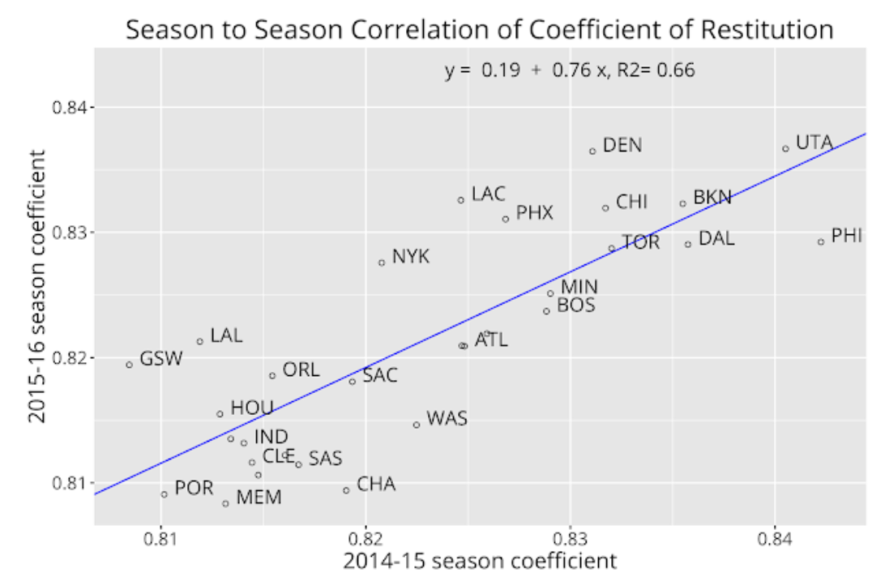
As you can see from the graph, some teams have a consistently higher or lower value of the coefficient of restitution. Coaches are known to manipulate this to benefit the playing style of their teams. Different basketball leagues have different ways of regulating the coefficient of restitution. These rules are summarized below. Utilize your knowledge of inelastic collisions and the processes that influence the coeffient of restitution to compare the relative effectiveness of the different rules.
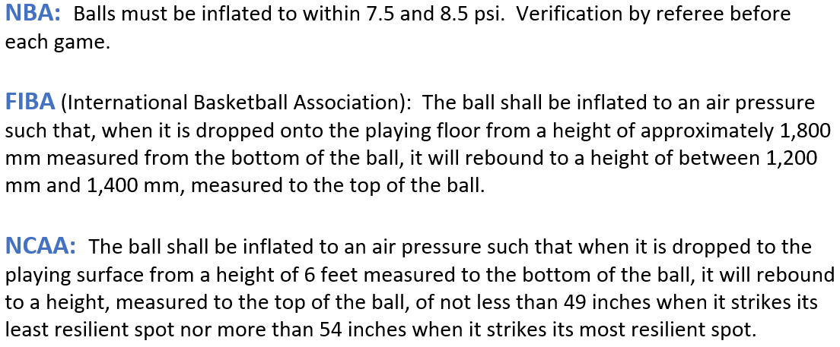
      - Often some of the simplest inventions require careful thought and a deep understanding of physics. How many of you have seen cabinet door bumpers that are designed to allow drawers to close smoothly and quietly? Using what you know about impulse and inelastic collisions, discuss the properties you would want to incorporate into the best bumpers.

