Science of Collisions: Activity 1
Energy Retained Following an Inelastic Collision

Name:______________________ Date:____________ Period:_____

Hypothesis: The mechanical energy retained by a bouncing ball can be determined by measuring the time between bounces and applying the kinematic equations of motion.

Guiding Questions:
Introduction: Collisions are happening all around us at microscopic and macroscopic scales. Understanding collisional processes is critical for scientists and engineering to describe how the world works, and in particular, how energy changes form during almost any process we observe. A bouncing ball can serve as a model system for characterizing and understand collisional processes.

- How is the energy of a ball changed if you pick it up from the floor and hold it in your hand?

- If you drop the ball, describe the how the energy of the ball is changing in terms of gravitational potential energy and kinetic energy?

- Do you expect the ball to bounce back to the original height from which your dropped it? Explain why the ball will not bounce back to the original height.

- If the ball has less mechanical energy after each bounce/collision, where did the energy go? Provide possible explanations.

- Consider the movement of a ball between bounces (i.e., the time between two sequential collisions with the surface). Use a reference frame where the acceleration due to gravity is negative and the height of the surface is zero. Examine the graphs below and select the graph that best illustrates the functional form for questions a-f below:
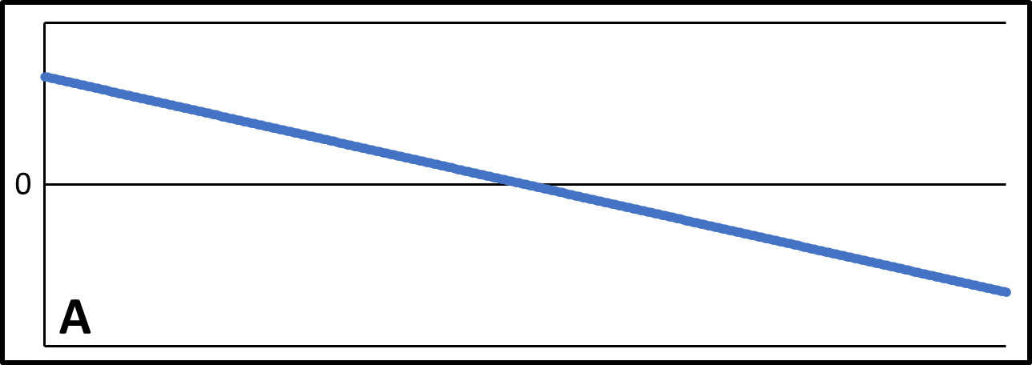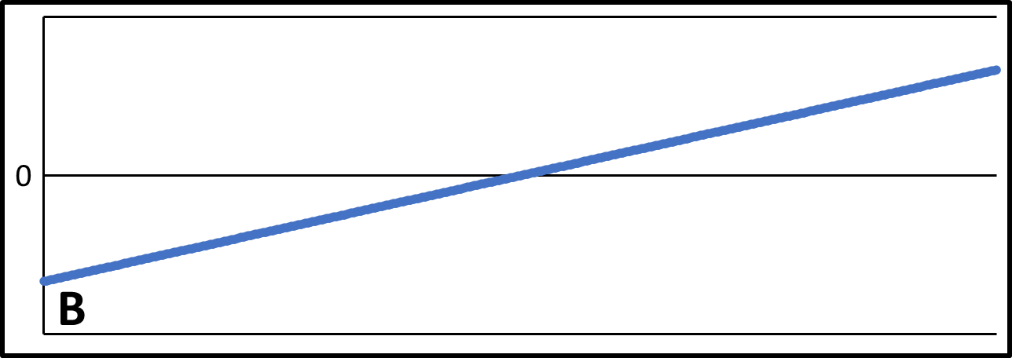

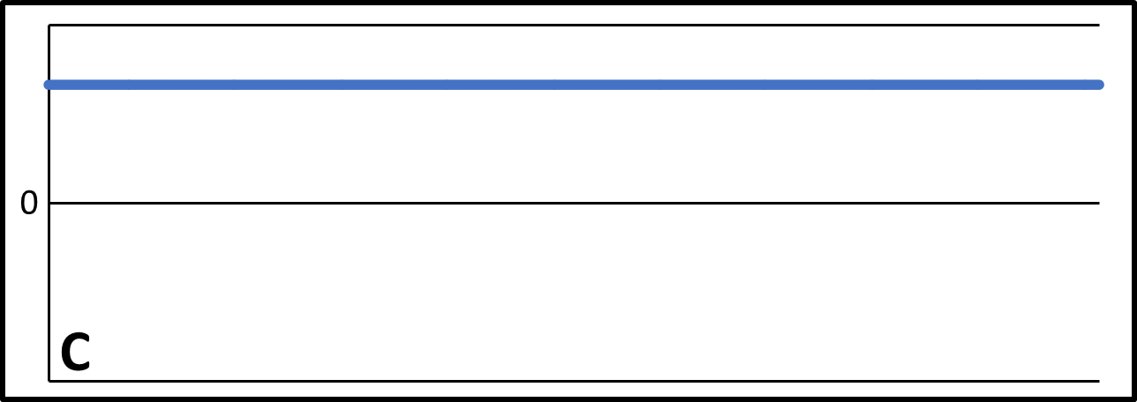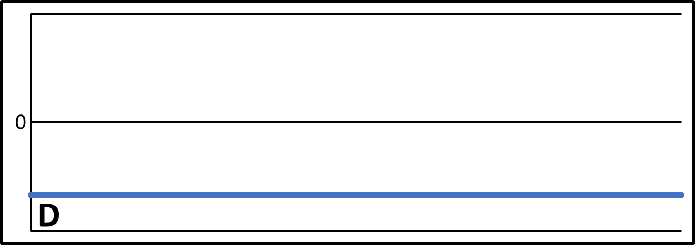

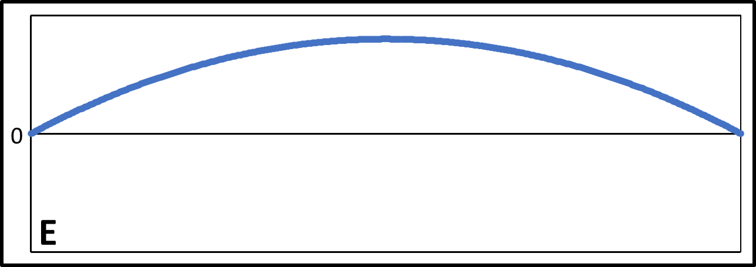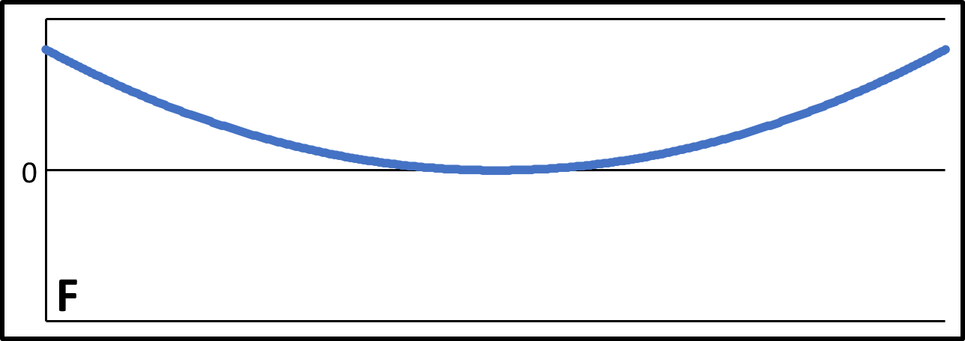
  - Position vs time of the ball?
  - Velocity vs time of the ball?
  - Acceleration vs time of the ball?
  - Potential energy vs time of the ball?
  - Kinetic energy vs time of the ball?
  - The total mechanical energy vs time of the ball?

Goals:
- Investigate the physics of inelastic collisions by applying knowledge of displacement, velocity, and acceleration.
- Develop scientific and engineering practices by exploring experimental designs and evaluating different measurement strategies.
- Explore gravitational potential energy, kinetic energy, and the conservation of mechanical energy.
Instructions:
Determine the energy retained by a bouncing ball from a measurement of the time between collisions. Thousands of physics students before you, have conducted this experiment by directly measuring the height of a bouncing ball by visual inspection and/or manual timing. In this experiment, you will use an accelerometer to measure the vibrations produced by each collision to determine the collision times and then use the time between collisions to calculate height and velocity of the ball.
    - Explore experimental designs which will produce a measurable vibrational signature as a result of collisions. Describe your final experimental design (type of ball, type of surface, drop distance, distance of phone from drop zone, …)

    - Collect acceleration data for ~5-7 bounces and record the initial drop height.
    - Graph acceleration vs time.

    - Using your graph and data values, determine the time of each collision
    - Use the kinematic equations for free fall, perform calculations for height and velocity that will allow you to determine the follow (and example data table is on the next page):
      - Maximum height following each bounce
      - Maximum velocity after each bounce
      - Maximum potential energy after each bounce
      - Maximum kinetic energy after each bounce
      - % Energy retained for both PE and KE

- The table values marked with “x” will be calculated using the times you measure (indicated by “Data” in the table). These calculations will be easier to perform using a spreadsheet since they are repetitive. You can make this spreadsheet on your own or your teacher can provide you with a spreadsheet that has already been developed to conduct this analysis. Show sample calculations illustrating how the values for each column in your table were determined.

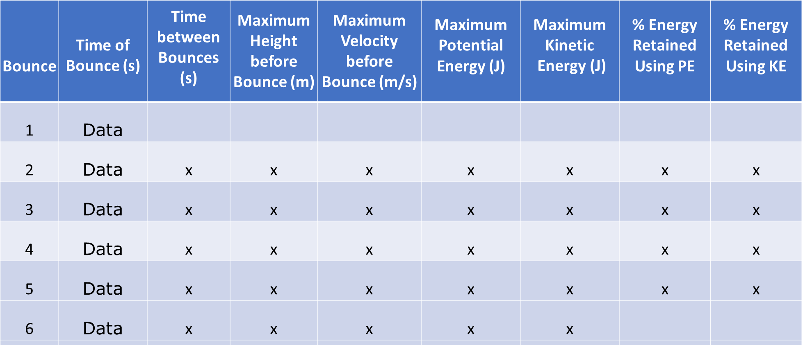

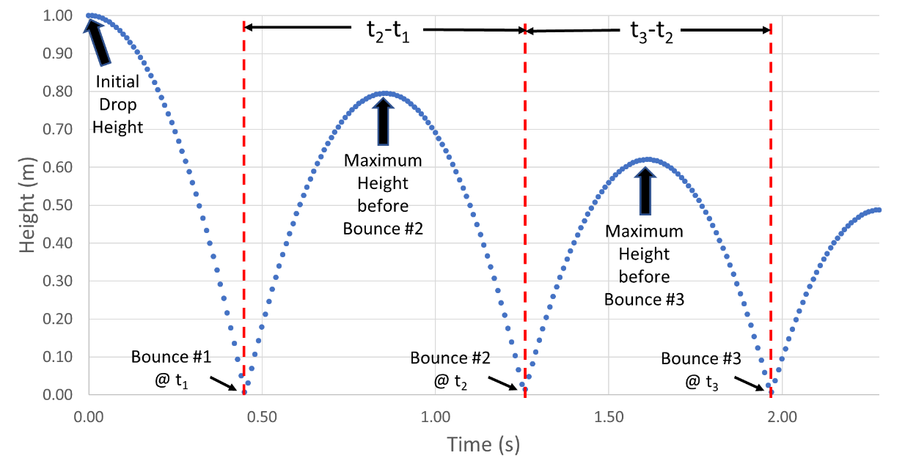

- Determine the average value of the retained energy.

- Using the average value for retained energy, calculate the initial drop height and compare the calculated value to your experimental value.

Analysis and Discussion:

- This experimental method depends on accuracy and precision in determining the time between each collision. Discuss the accuracy and the precision of using the accelerometer to determine the time of each collision. How much did the precision of your measurement impact the precision of the average energy retained?

  - How do you think this approach might compare in accuracy and precision to visual measurement of height?

  - How might you improve the precision of time measurement between collisions?

- The percent energy retain is written as:

Using the definition for potential energy, show why the percent energy retain can also be written:

- When you calculated the average energy retained you averaged the values determined for each sequential bounce. Based on these individual values, make a hypothesis on how the energy retained depends on the velocity of the ball prior to the collision?

  - What would you expect to observe if the energy retained was dependent on the velocity of the collision?

- The energy for a bouncing ball is shown in the graph below. In your own words, describe what is happening to the gravitational potential energy, kinetic energy and total mechanical energy during the times specified below.

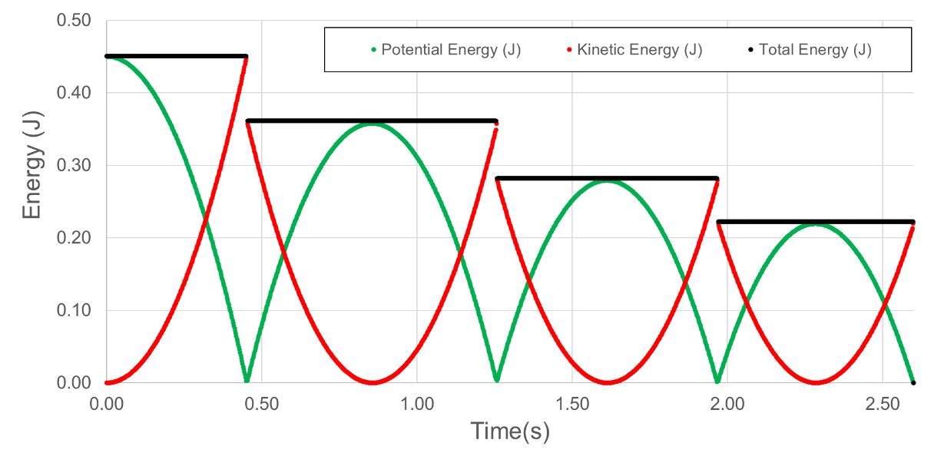
  - The time just prior to a collision compared to the time just after the collision

  - During the time immediately after the ball leaves the surface following a collision until the time just before it collides with the surface again. Explain in terms of conservation of energy.

Extension Question:
- The precision of the timing measurement can be significantly improved by measuring the soundwave produced by the collision with the microphone in your phone. This is possible because microphones can collect data at very fast rates (e.g., 48,000 points per second for the data below). The data for a golf ball bouncing on a wooden desk is shown below. The second graph shows an expanded view of the sound wave with data points taken every ~0.00002 seconds.
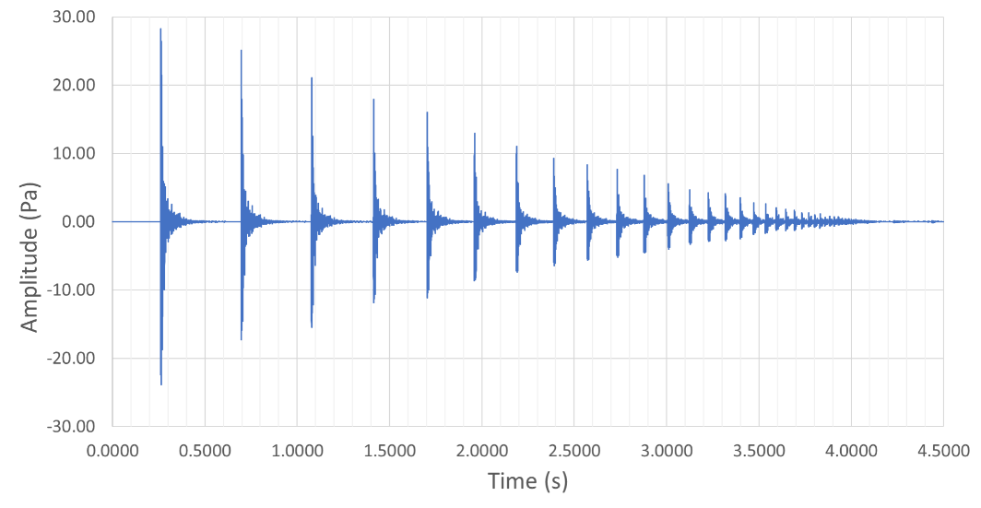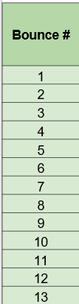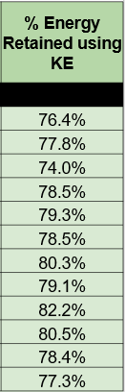
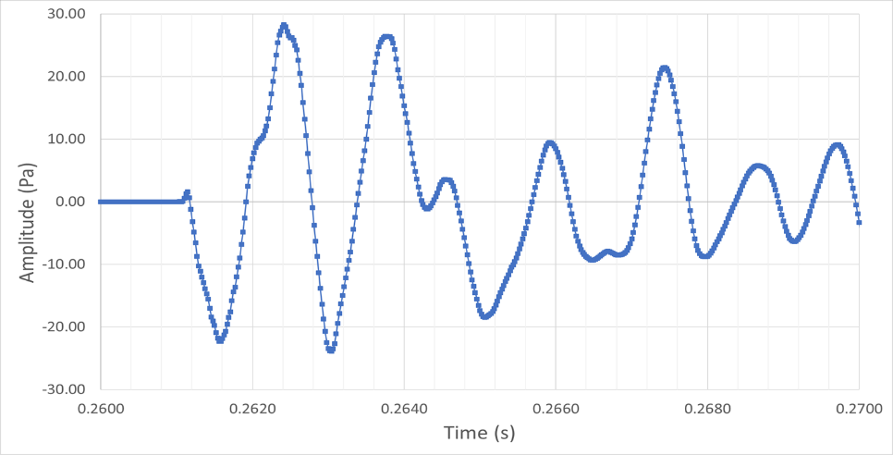

The time between collisions can be measured to 3 significant figures. As can be seen from the table, the percent energy retained is shown to have differences of a few percent for individual collisions. This suggests that the variations in the retained energy represent real variations in the collision processes which can now be observed using the improved measurement approach. Provide a hypothesis what is causing this variation?

