Mechanical Waves and Sound: Activity 7
Standing Waves and Resonances in Air Columns
Name:______________________ Date:____________ Period:_____

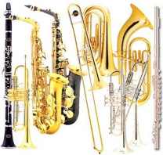
Hypothesis: Sound waves propagating in pipes can form stable standing waves at unique frequencies (i.e., resonances) that depend on the length of the pipe and the speed of sound in the medium inside the pipe.

Guiding Questions:
Introduction: We know that waves can be reflected when they encounter a change in the medium in which they are propagating. This is very apparent in the case of a guitar string that is fixed at both ends. The displacement of the guitar string is zero at the fixed ends, defining nodes in the displacement. These boundary conditions define the wavelengths of the standing waves that can be amplified by the interference between the initial disturbance and the waves reflected from the boundaries. This physical property, where only certain frequencies of oscillation are allowed is called quantization and is a fundamental property that helps us better understand and describe the world around us.
In this activity we will study the reflection of sound waves that take place when they reach a boundary at the end of a pipe. Reflections can take place from both closed and open ends of a pipe. The resonant frequencies, which result from constructive interference, are the basis of the beautiful music produced by wind instruments such as trumpets, flutes, and saxophones.
Let’s explore the physical principles of molecular movement in pipes that define the boundary conditions, and hence the resonant frequencies.
- We know that molecules move back and forth as a sound wave propagates through air. We also know the net movement of the molecules is zero after the sound wave passes. How might you describe the molecular movement that results from a sound wave as it reaches the end of a closed pipe? Choose one.
- Very little displacement near the solid end wall because molecular movement will be constrained.
- No change in the molecular displacement over the length of the pipe

- Analogous to the guitar string, the limited molecular displacement near the end of a closed pipe will result in a displacement _______?
  - Node
  - Antinode

- How would you describe particle movement in a sound wave as it reaches the end of an open pipe? Choose one.
  - Reduced displacement at the open end of the pipe due to atmospheric pressure
  - No change in molecular displacement over the length of the pipe
  - Molecules will undergo maximum displacement near the open end of a pipe because their movement is not constrained by solid walls

- The maximum displacement near the open end of a pipe with result in a
displacement ________?
  - Node
  - Antinode

- We have described sound waves as periodic compression and rarefaction of molecules in air. If we look at the pressure disturbances in a standing wave in a pipe, we discover that the pressure and displacement nodes and antinodes are out of phase. At the open end of a pipe, where there is maximum in displacement amplitude, there is a minimum change in the pressure amplitude. At the closed end of a pipe there is a minimum in the displacement amplitude, there is a maximum in the amplitude of the pressure change. Explain why you think this is the case.

- The figures below display the resulting resonances that result from the standing waves that form in open and closed pipes. The resonances follow the rules we just determined for nodes in the displacement at the closed end of a pipe and antinodes at the open end of the pipe. The resonances start with the smallest possible fraction of a wave and continue to introduce higher harmonics. Note that the blue lines represent the displacement or motion of molecules. The red lines indicate the change in pressure.
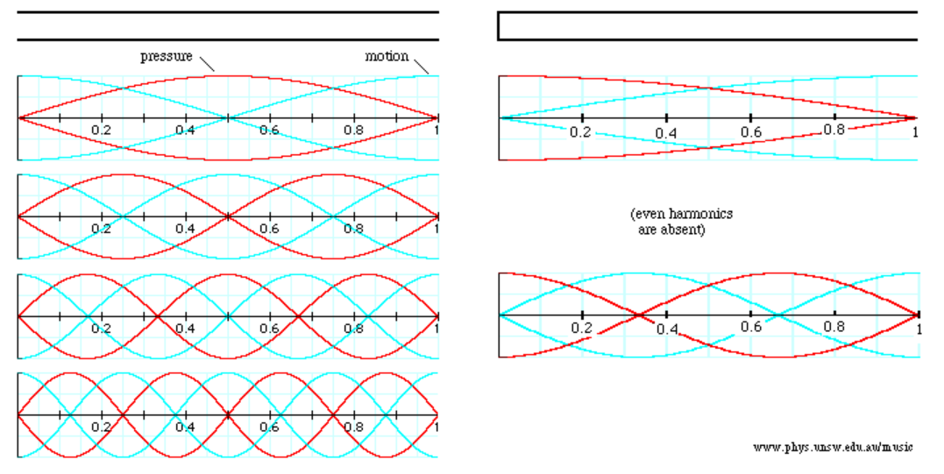
  - What is the relationship between wavelength of the resonant wave and the length of the pipe for both open and closed pipe resonators? Complete the table.
Harmonic | Open Pipe | Closed Pipe
First | λ₁ = 2L | λ₁ =
Second | λ₂ = | -
Third | λ₃ = | λ₃ =
Fourth | λ₄ = | -
Fifth | λ₅ = | λ₅ =

  - Using the relationship between frequency, wavelength, and wave speed, complete the following table.
$$f=\frac{v}{λ}$$
Harmonic | Open Pipe | Closed Pipe
First | $$f_{1}=\frac{v}{2L}$$ | $f_{1}=$
Second | $$f_{2}=$$ | -
Third | $$f_{3}=$$ | $$f_{3}=$$
Fourth | $$f_{4}=$$ | -
Fifth | $$f_{5}=$$ | $$f_{5}=$$

Goals:
- Explore the physical origins of resonance/quantization that result from the interference of waves constrained by boundary conditions.
- Predict the resonance patterns for open and closed pipe resonators by understanding the physical movement of molecules and then visually validate the predictions using simple experiments.
- Make connections between music and the resonances produced by interference.
- Reinforce basic properties of waves and the nomenclature used in describing them such as reflection, interference, nodes, antinodes, boundary conditions, standing waves, resonance, amplitude, wavelength, wave speed, and frequency.
Instructions:
  - String Resonator: Using the phyphox (audio scope), observer the pressure disturbance that is produced by singing or humming a constant note. Use a 50 ms full scale. Take a screen shot and insert the graph below.

    - How does the pattern compare to that observed for a whistle?

    - Discuss some possible explanations for the complex patterns that you observe?

  - Using a frequency analysis application such as SpecrtumView or phyphox (audio spectrum – history tab), observe the frequencies produced by singing a constant “note” for about 5 seconds. Insert a screen shot of the graph below.

    - Is the frequency pattern consistent with what you might expect for a string resonator? Explain.

    - What is the lowest fundamental frequency you can produce?

    - What is the highest fundamental frequency you can produce?
  - Open pipe resonator: Blow gently over the top of a straw with the other end of the straw close to your microphone. Use a frequency analysis application to measure the resonance frequencies. Insert a screen shot of the graph of your data and record the frequency for each harmonic. Measure and record the length and the diameter of your straw. Note the approximate temperature of the room.

Harmonic | First | Second | Third | Fourth | Fifth
Frequency

  - Closed pipe resonator: Blow gently over the top of a straw with your finger covering the other end of the straw. Adjust your position so the resonance sound waves from the straw are directed toward the microphone but you are not blowing directly into the microphone. Use a frequency analysis application to measure the resonance frequencies. Insert a screen shot of the graph of your data and record the frequencies for each harmonic.

Harmonic | First | Second | Third | Fourth | Fifth
Frequency
Analysis and Discussion:
- Hopefully you were able to modify the frequencies of your voice. Provide a possible explanation of how you were able to increase the fundamental frequency of the note you were singing.

- Complete the following table for your open pipe resonator data.
- Calculate the wavelength from the measured frequency and the effective straw length, L_{effective}.
  - Use the relationship: L_{effective} = L + 0.6 x Diameter, to calculate the effective length of your “pipe”. This correction is needed because the effective boundary of where the sound wave is reflected extends slightly beyond the end of the straw.
- Finally, calculate the speed of sound using the measured frequencies, the calculated wavelengths, and the relationships between for the various harmonics you developed in the guiding questions.

Open Pipe Resonator
Harmonic | Measured  Frequency (Hz) | Calculated  Wavelength (m) | Calculated Speed of Sound vs(m/s)
f1
f2
f3
f4
f5

  - Compare your calculated speed of sound with the value you expect for the temperature of your experiment.

  - Write a general formula for the resonant frequencies, f_{N}, in terms of N and the fundamental frequency f₁ for an open pipe resonator.

f_{N} = For N = 1, 2, 3, …
- Complete the following table for your closed pipe resonator data.
- Calculate the wavelength from the measured frequency and the effective straw length, L_{effective}.
  - Use the relationship: L_{effective} = L + 0.3 x Diameter, to calculate the effective length of your “pipe”. This correction is half that for the open pipe because only one end is open.
- Finally calculate the speed of sound using the measured frequencies, the calculated wavelengths, and the relationships between for the various harmonics you developed in answering the guiding questions.

Closed Pipe Resonator
Harmonic | Measured  Frequency (Hz) | Calculated  Wavelength (m) | Calculated Speed of Sound vs(m/s)
f1
f2
f3
f4
f5

  - Compare your calculated speed of sound with the value you expect for the temperature of your experiment.

  - Write a general formula for the frequency of a harmonic, f_{N}, in terms of N and the fundamental frequency f₁ for a close pipe resonator.

f_{N} = for N = 1, 3, 5, …

Extension Question:

- Consider the frequency pattern below for a pipe resonator.

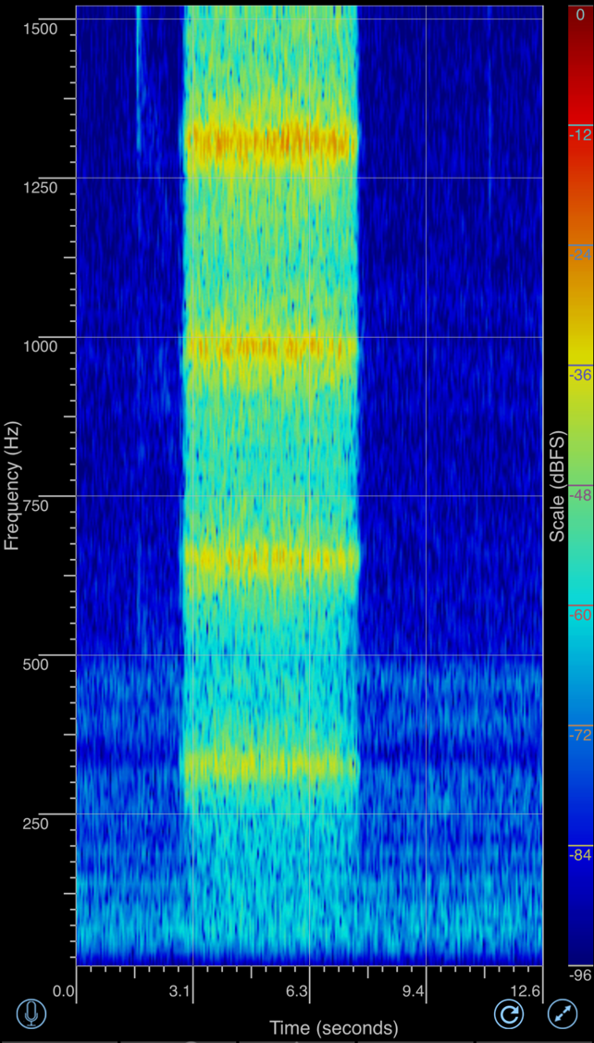

  - Is this an open or closed pipe resonator? Justify your answer.

  - What is the approximate length of the pipe? Show your calculations.

- Speech Recognition: The graphs represent the frequency signatures for the four spoken words: physics, sound, light, and magnetism. Each word is spoken twice in a row. Measure the frequency signatures when you speak the words and see if you can determine the order the words were spoken below.
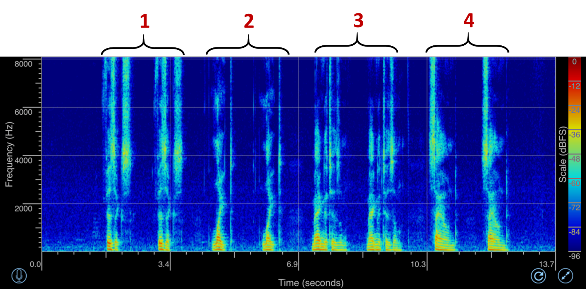

1)
2)
3)
4)

