Mechanical Waves and Sound: Activity 6
Constructive and Destructive Interference of Sound Waves with Different Frequencies
Name:______________________ Date:____________ Period:_____

Hypothesis: The interference of two sound waves at different frequencies will produce temporal patterns of the wave amplitude, in contrast to the spatial patterns observed from the interference of sound waves with identical frequencies.

Guiding Questions:
Introduction: We began the investigation of interference with sound waves of the same frequency. The resulting interference produced amplitude oscillations that varied spatially. We could experimentally identify specific locations in space where the waves constructively or destructively interfered.
Interference of sound waves with different frequencies creates a much more interesting world. When two sound waves with different frequencies are observed at a point in space, their oscillations are periodically in and out of phase. In other words, the waves temporally alternate between constructive and destructive interference.
Consider the simple case of two sound waves, produced by two spatially separated sources, that have different frequencies (in this example, F1 is twice F2) and different amplitudes.
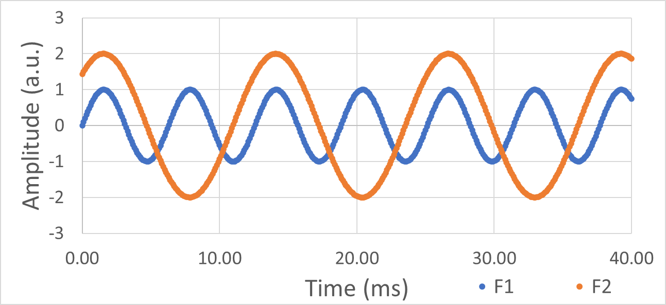

- Identify locations on the graph where the sound waves have maximum constructive and destructive interference (mark with a “c” or “d”).
  - Sketch the sum of the two sound waves on the graph.

- Consider the two sound waves with slightly different frequencies illustrated in the figure below.
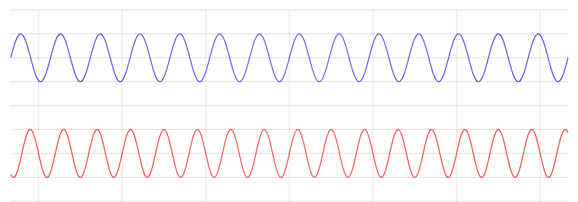
Time
  - Indicate the times on the graph when the two waves are in phase and the sum of the two waves have maxima in amplitude due to constructive interference. Also indicate the times where the two waves are ~½ wavelength out of phase and have a minima in amplitude due to destructive interference.

  - Describe the general shape of the sound wave produced by the interference. What do you think you might hear if you listened to these two sound waves interfering?

Goals:
- Investigate the temporal interference patterns that result from the constructive and destructive interference of two sound waves with different frequencies.
- Experimentally investigate the “beats” that result from the interference of two sound waves with different frequencies.
- Demonstrate the remarkable quality of the interference patterns predicted by models with experimental data.

Instructions:
In this experiment you will use the experimental geometry shown schematically below (similar to activity 5). This setup uses: three phones, two devices with speakers and your phone; or one device with stereo output (e.g., earphones) and your phone. Place the speakers in proximity to each other and direct them toward the location where the combined sound wave will be detected. There are many applications available that generate multiple tones with control of right and left outputs. One example experimental design is shown in the photo.

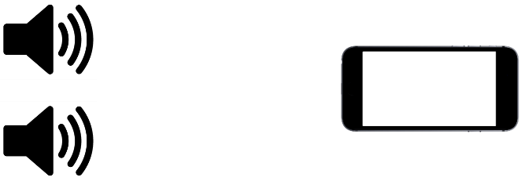
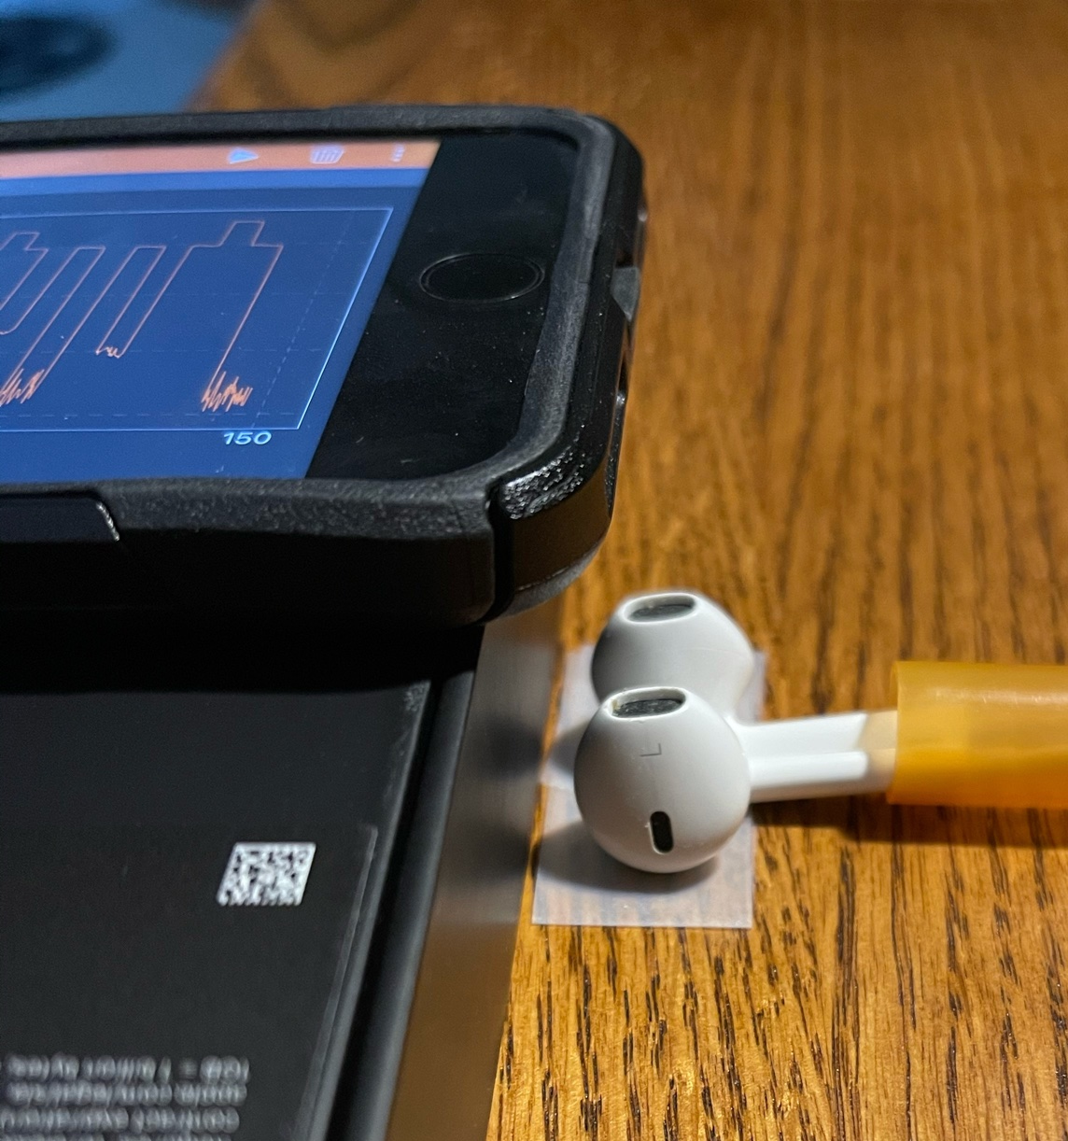

  - Explore “Beats”: Use two speakers to produce frequencies at 500 Hz and 504 Hz.
    - Describe what you hear when both speakers are vibrating and producing their respective tones?

    - Explore what happens as you adjust the second tone several Hz higher or lower. Describe what you hear.

    - Capture the sound wave using phyphox (audio scope) for the initial case of 500 Hz and 504 Hz. Insert a screen shot of the graph below.

  - Quantify “Beats”: Use two speakers, with similar intensity (i.e., “volume”) to produce frequencies at 1000 Hz and 1100 Hz.
    - Use phyphox (audio scope) to record the pressure oscillations for each of the individual frequencies playing one at a time. Use a time scale of 50 ms so you capture many oscillations. Export the files for analysis.
    - In a similar way, recorded the combine sound waves when both frequencies are playing. Export the file for analysis.

Analysis and Discussion:

- Estimate the beat frequency from the graph of the data you collected for the interference of sound waves at 500 Hz and 504 Hz.

  - Based on your limited experimental data, predict the beat frequency you expect will result if the input frequencies are 500 Hz and 502 Hz.

  - Describe how you could use your ability to hear the changing frequency of beats to tune the frequency of an instrument to a match another known frequency?

- Let’s analyze the data you collected at 1000 Hz and 1100 Hz in more detail. Using the files you have saved, create a new spreadsheet that combines the data for the sound waves at the two frequencies.

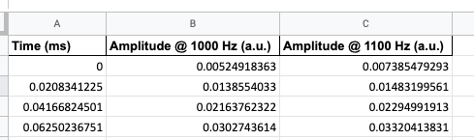

  - Graph amplitude vs time for one of the data sets and measure the period, T. Calculate the frequency from the period and compare the frequency to the expected value set by the tone generator. Insert your plot below, show your calculations and annotate the graph showing how you measured the period.

  - Now, remembering that wave amplitudes simply add when they interfere, sum the amplitudes of the two sound waves in your spreadsheet and create a graph of the result. Insert the graph below.

  - Finally, graph the experimental data for the sound wave produced from the interference of the 1000 Hz and 1100 Hz sound waves. Insert the graph below.

  - Compare the calculated sum of the two sound waves to the experimental measurement of the interfering sound waves. How well do they agree? Discuss your comparison.

- Carefully determine the beat frequency from your experimental data of the 1000 Hz and 1100 Hz sound waves interfering. Include a description how you determined the beat frequency with the highest degree of accuracy possible using your data.

- Analyze several oscillations, during times when the two sound waves have maximum constructive interference, to determine the observed frequency of the oscillations of the interfering sound waves.

- Below is a table containing a series of experimental measurements for two interfering sound waves of different frequencies. Using the data in this table and your own observations, make a hypothesis of the mathematical relationship between: 1) two input frequencies and the beat frequency, and 2) two input frequencies and the observed frequency.
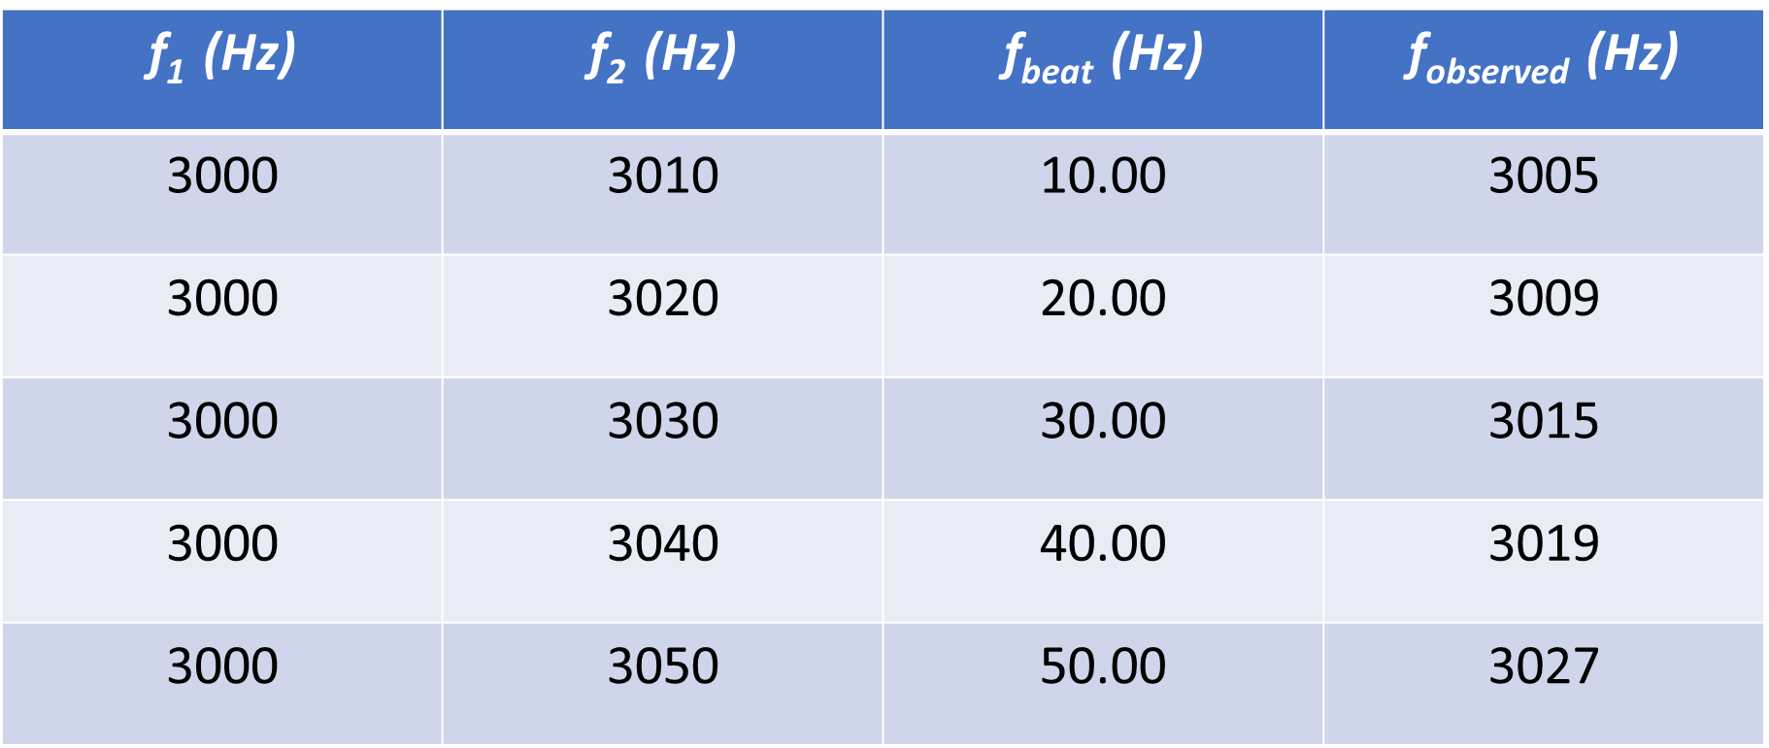

$$f_{beat}=$$

$$f_{observed}=$$

Extension Question:

- Consider the beat pattern below. What frequencies were responsible for this beat pattern?

