Mechanical Waves and Sound: Activity 3
Measuring the Intensity of Sound Waves as a Function of Distance
Name:______________________ Date:____________ Period:_____

Hypothesis: The intensity of a sound wave decreases as the inverse square of the distance from the source.

Guiding Questions:
Introduction: The intensity of a sound wave is a measure of the amount of energy that is transported through a given area of a medium per unit of time. The greater the amplitude of the vibrations of the particles of the medium, the greater the intensity. Everyone has experienced that the closer they are to the source of a sound, the louder they perceive the sound. The ability of humans and animals to detect sound waves at a distance is very important and the rate at which the intensity decreases with distance has significant consequences.
- Provide two examples, one for humans and one for an animal where this relationship between sound intensity and distance is critical to a specific situation. Describe how various scenarios might change significantly if sound intensity decreased as 1/d³ vs 1/d, where d represents distance. (e.g., You might consider students talking in the back of the classroom or a predator-pray engagement.)


- When a firework explodes in the sky, the sound wave propagates away from the initial explosion. Describe what you think the sound wave might look like in terms of direction from the initial explosion.

  - As the sound wave propagates from the source, does the overall energy of the sound wave change?
  - Are more molecules involved in propagating the sound wave as it moves further away from the initial explosion?
  - How might the number of molecules involved in propagating the sound wave change with distance? Would it be reasonable to think it depends on the surface area of a sphere?
Goals:
- Experimentally measure the decrease in intensity of a sound wave as a function of distance from the source and demonstrate the inverse square law relationship.
- Provide students the opportunity to characterize sound intensity of common sources using a logarithmic scale (i.e., measurements in decibels).
- Instruct students to fit experimental data to simple functions and determine the relationships between variables from graphical analysis.

Instructions:

- Download an application (e.g., Decibel X) for measuring the Sound Pressure Level (SPL) in decibels. Use the application to measure the SPL for different sounds around your home or school. Fill in the table below for a few different sounds (e.g., quiet room, casual talking, TV on, noisy classroom, music playing loudly).

Source | Average  SPL (dB)

  - Move away from a sound source and observe the general trend in the observed SPL. Qualitatively describe your observation.

- Design an experiment to quantitatively measure the change in intensity of a sound wave as a function of distance by measuring the SPL in dB.
  - Use two phones: One phone to generate a constant intensity of sound and the other to detect the sound intensity at different distances.
    - Phone 1: Use a white noise generation application to create the constant sound intensity.
    - Phone 2: Use a sound measurement application such as Decibel X to measure the SPL.
  - Minimize potential interference from reflected sound waves by making the distance of your measurement >2x the distance to objects such as floors, walls or the experimentalist.
    - Measurements at distances of 10 cm, 15 cm, 20 cm, 25 cm and 30 cm will be sufficient to determine the functional dependence. Insert the measured intensities in a table. The relative influence of reflected waves will be greater and difficult to eliminate as the distance become longer.
  - An example experimental design is provided below. (Teachers can remove this description if they want students to attempt to develop independent designs.)

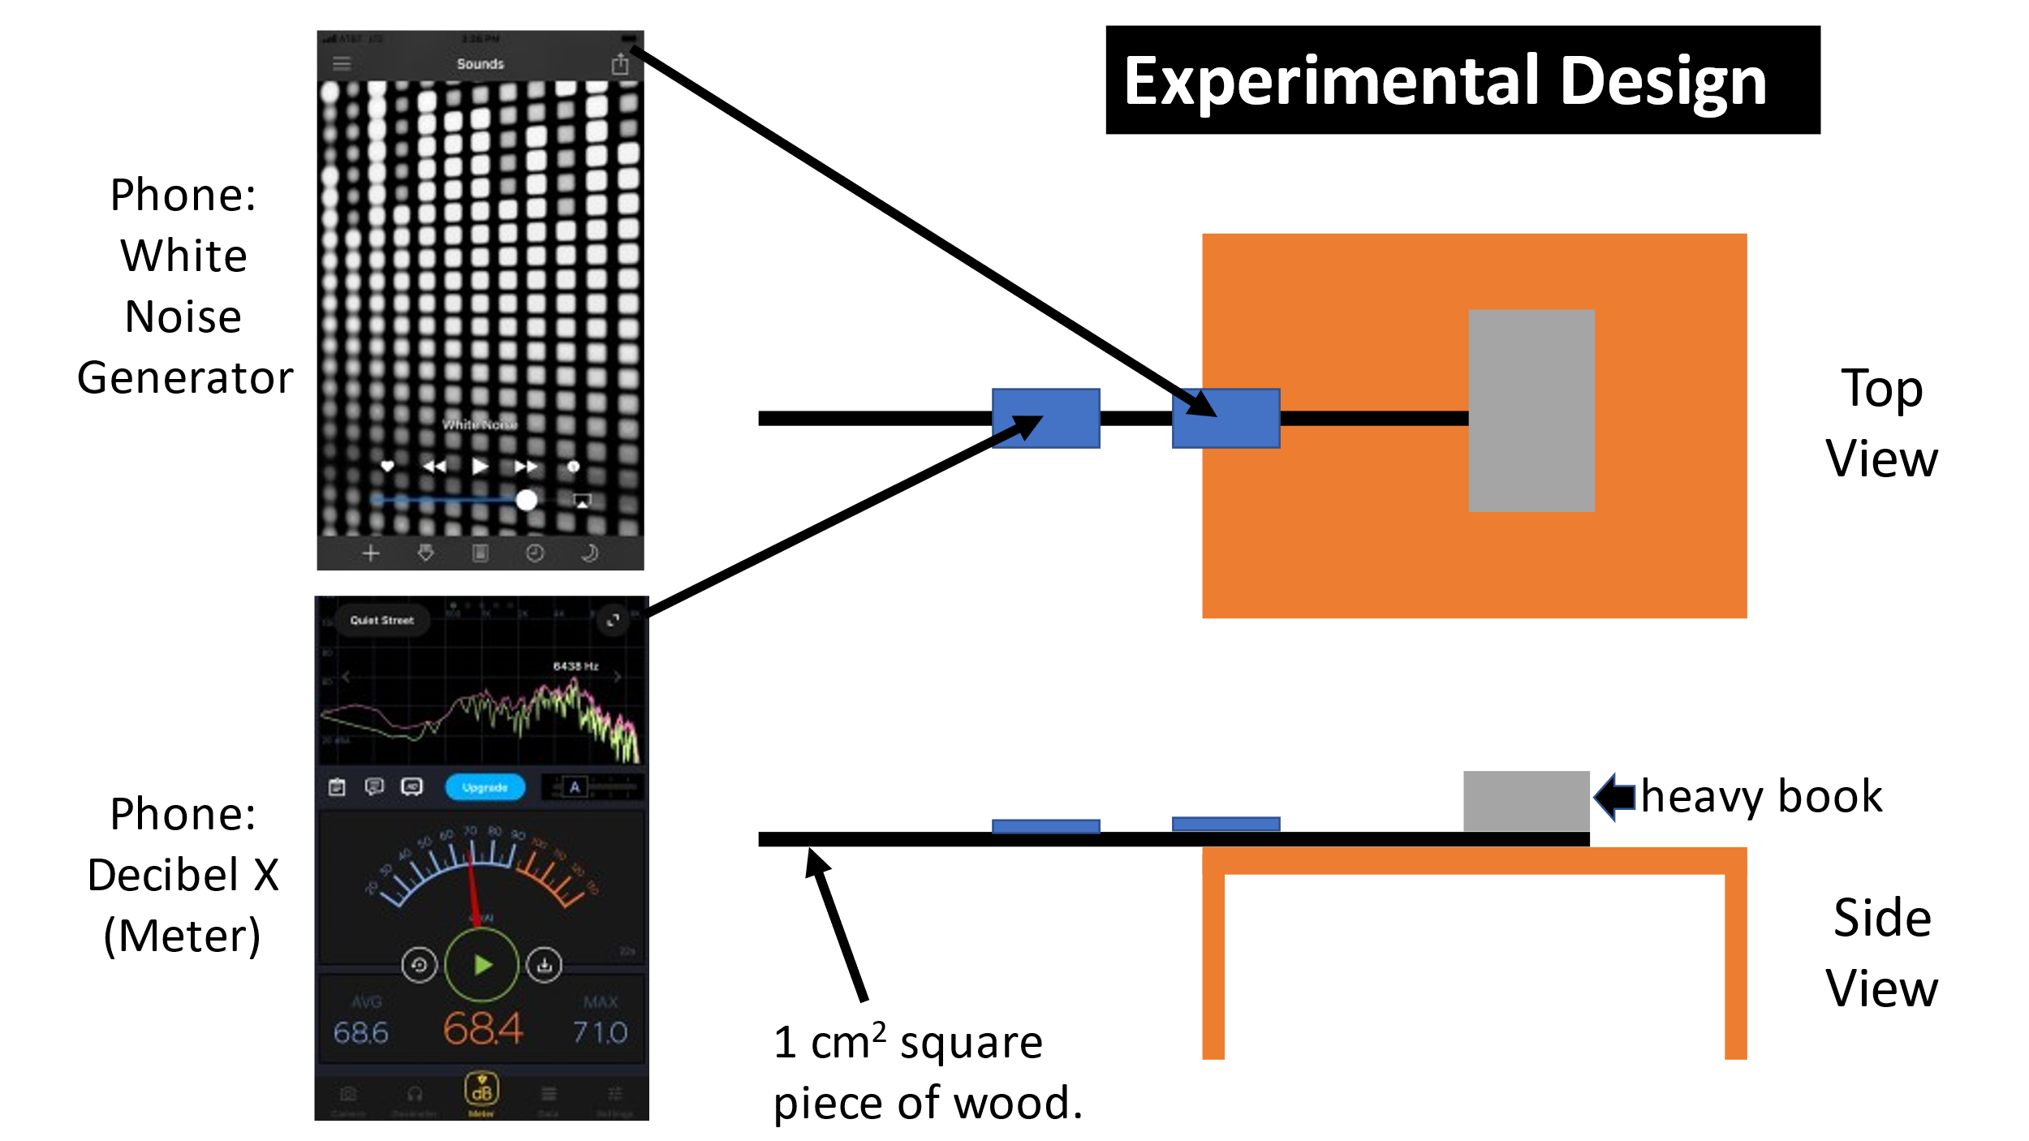

Distance from Source (m) | Intensity (dB)
Analysis and Discussion:

- Compare your measurements of SPL to values in your textbook or other reliable sources you might find on the internet. Are the measured values of the sound intensity consistent with expected values? Discuss.

  - What is the approximate (i.e., order of magnitude) difference in intensity between the quietest measurement and the loudest?

- Insert your data, from Part 2, in the following table and calculate the intensity of the sound waves in W/m², using the relationships provided. Show an example calculation below.

Distance (m) | SPL (dB) | 1/d² (m⁻²) | Intensity (W/m²)

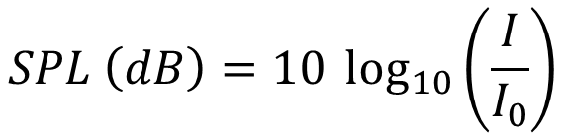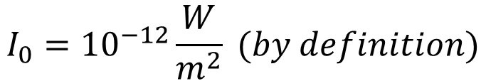

- Plot intensity vs distance using a spreadsheet and fit the data.

  - What is the relationship between intensity and distance as determined from your data?

- Plot the measured intensity vs 1/d². Include a linear fit to the data.

  - Is your data consistent with the original hypothesis that the intensity of sound decreases with the inverse square of distance from the source? Explain.

Extension Question:

- The intensity of a sound wave is proportional to the square of the amplitude. In the case of a sound wave propagating in air, the amplitude of the mechanical wave is the change in pressure from the equilibrium value of pressure at that location. Using your understanding of the change in intensity as a function of distance, predict the change in the peak pressure of a sound wave as a function of distance?

  - Describe an experiment which could be used to validate your prediction. (Teachers could ask students to conduct the experiment as well.)

