Mechanical Waves and Sound: Activity 2
The Physics of a Human Whistle – A Model Sound Wave

Name:______________________ Date:____________ Period:_____

Hypothesis: A human whistle produces a periodic pressure disturbance that can be characterized as having a well-defined frequency.

Guiding Questions:
Introduction: Sound waves are longitudinal waves where energy is transmitted from one location to another by the periodic motion of molecules/atoms in a medium. A sound wave is initiated by a vibration, and it can be detected at a second location by measuring the time varying pressure. Sound waves can be characterized by their period of oscillation, amplitude, and wave speed.
- Have you “felt” the pressure fluctuation of sound waves? Describe a situation when you have felt sound waves.

- What are 3 examples of vibrating objects that produce sound?
Example: A basketball bouncing on a gym floor, where both the vibration of the air inside the basketball and the vibration of the wooden floor produces sound waves.

- If you blow air through your mouth and lips just right, you can create a sound wave that we call a whistle. Describe what you think that sound wave might look like physically in the air as it propagates across the room to others, who can detect it with the complex biological machinery in their ears. Consider what physical properties might be useful in describing a sound wave. Don’t worry about being wrong, you will discover more about sound waves during this activity.

Goals:
- Develop a physical understanding of a sound wave as a periodic oscillation of pressure in time by visually observing a sound wave at a well-defined frequency.
- Learn how to define the characteristics of waves and become familiar with the terms used to describe them such as period, frequency, amplitude, and wavelength.
- Learn to use tools which transformation amplitudes in the time domain to amplitudes in the frequency domain. Explore the variety of graphs that are used to communicate information about the amplitude of sound waves in both domains.
Instructions:

- The microphone in your phone is able to measure very small changes in pressure at very high speed. Using the phyphox (audio scope application) to access the signal from the microphone, measure the pressure fluctuations in a quiet room. Use multiple time scales by selecting the time below chart and adjusting the scale. Insert several examples screenshots of your data.

  - Describe what you observe and explain what you think is responsible for the changes in pressure detected by the microphone.

- Use the phyphox (audio scope application) to measure the sound wave produced from a human whistle. Insert a screen shot of the data below. Save (export) your data to a file for later analysis.

  - Describe your observation?

  - Using the “pick data” feature in phyphox to measure the period of the oscillations of the sound wave. Use these times to calculate the period and frequency of your whistle.

- A mathematical method, called a Fourier transform, can decompose a time dependent signal, such as the amplitude vs time signals you have just measured, into its constituent frequencies. There are multiple applications on your phone that will perform this calculation. The resultant graph shows the relative contributions of various frequencies of oscillation to the sound wave being detected by the microphone. Using phyphox (audio spectrum), determine the primary frequency of your whistle.

  - Insert the graph from the spectrum tab and indicate the measured frequency.

  - Insert the graph from the history tab and indicate the measured frequency.

  - Explore at least one additional application for frequency analysis such as: SpectrumView (IOS), SprectralView Anaylzer (Android) or Advance Spectrum Analyzer PRO (Android). Insert a graph from one of the other applications.

- Determine the frequency of a whistle using multiple phones (or other devices) simultaneously. Use different applications on each of the devices. For one of the applications, include audio scope with manual analysis. Include graphs of your data below.

Analysis and Discussion:

- Using your audio scope data for a whistle collected in part 2, graph several full periods of oscillation using your favorite spreadsheet application. Annotate your graph indicating the period and amplitude of the oscillations.

  - Using a wave speed of 344 m/s, calculate the wavelength of the sound wave produced from your whistling. How does this result compare with your initial expectation?

  - At any instant in time, the sound wave from your whistle has created a spatial variation in air pressure where the regions of high pressure are separated by one wavelength as shown in the graph below. This behavior of a sound wave should remind you of a harmonic oscillator. Explain this diagram using the terms: restoring force, equilibrium, and harmonic motion. Describe how collisions at the molecular level are resulting in net forces accelerating molecules in different directions as a function of time.

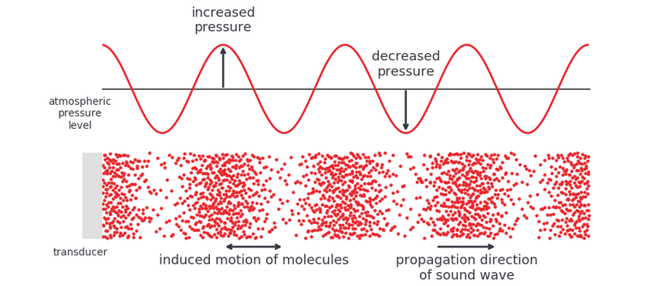
- Complete the table below comparing the frequency of a whistle determined using three different approaches.

Method | Frequency

  - Discuss the merits of the different approaches and how the different types of graphs were useful in your quantitative and qualitative analysis of the whistle.

Extension Question:

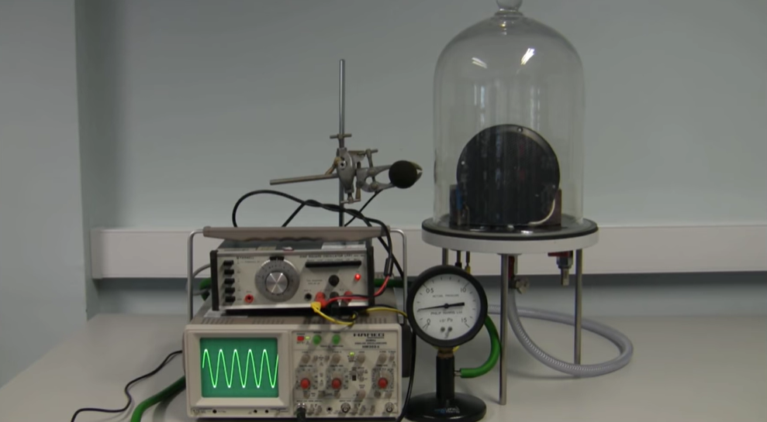
Watch the following video where a loudspeaker is producing a sound wave in container while the air removed using a vacuum pump. Explain the observations. Loudspeaker in a Bell Jar - YouTube

