Mechanical Waves and Sound: Activity 1
Exploring Wave Phenomena

Name:______________________ Date:____________ Period:_____

In this activity, you will be designing an experiment to document a fundamental property of mechanical waves using video and/or audio recording. Your findings will be incorporated into a multi-media presentation that can be used to communicate the results to your classmates.

Guiding Questions:
Introduction: Exploring the properties of mechanical waves provides a foundation for understanding of the physical principles that underly all wave phenomena. With that basic understanding, you will be able to investigate the rich topics of sound, earthquakes, radar, light, and electromagnetic waves, which are the foundation of our communications systems. Consider some of these questions about the basic properties of waves:

- How do transverse and longitudinal waves differ?
- What happens to a mechanical wave when it reaches a fixed boundary?
- When a mechanical wave reaches a boundary, what properties influence the reflected and transmitted wave?
- How does wave speed depend on the material properties of the media in which it is traveling?
- How do vibrating objects transfer energy through mechanical waves?
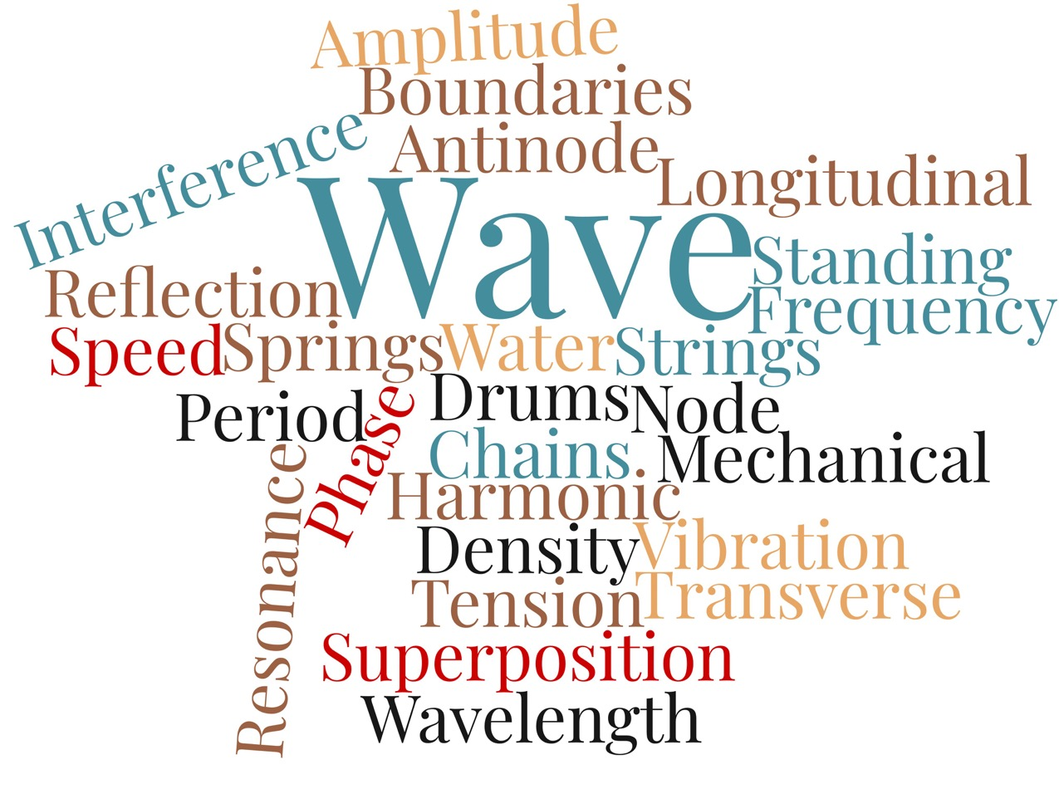
- Explore the world around you and see if you can find examples of some these wave phenomena. List 3 examples below.

Goals:
- Enable students to independently design and conduct an in-depth investigate of a basic property of mechanical waves.
- Provide students practice in their communications skills through their development of a multimedia presentation and the opportunity to clearly and persuasively share their findings with fellow students.
- Help student improve their communication skills by meticulously listening to other students present their findings by observing a range of effective (and ineffective) communication practices.
- Introduce students to a wide range of mechanical waves properties through the series of shared investigations.

Instructions:

- Design an experiment that will allow you to address one of the topics identified in the guiding questions. Your experiment should include a short visual or audio demonstration which can be used to illustrate the phenomena to your classmates. (Teachers may want to have students get approval before moving to part 2.)

  - What mechanical wave property will you investigate?

  - Describe the experimental approach you will use to investigate and demonstrate the phenomena.

- Create an outline of your presentation. Write down your thoughts using the format below to help organize your ideas:

  - Introduction:

  - Claim:

  - Evidence/Observation:

  - Reasoning:

- Create a multimedia presentation that can be shared electronically or presented to the class. (Teachers can decide on the best format for their class.)

Analysis and Discussion:

- Provide a summary of the properties of mechanical waves that were presented by four of your classmates. Include a statement about a specific component of the presentation that was most effectiveness in communicating their findings to the audience. If possible, choose different phenomena.

Classmate | Summary of Presentation

Extension Question:

- Using your experience from your own experiment and from observing the presentations of your classmates, what modifications might you make to your original experimental design if you were to repeat this activity?

- What modifications might you make to your original presentation to improve the effective knowledge transfer of your experimental findings to your classmates?

