Investigating Impulse and Momentum: Activity 2
Engineering Approaches to Reduce Momentum Transfer in Systems following an Impulse

Name:______________________ Date:____________ Period:_____

Hypothesis: The transfer of momentum in a system can be significantly reduced by implementing engineering modifications. Altering the maximum force by extending the time of the impulse is one approach that can be included in the system design to reduce momentum transfer to the object you want to protect from experiencing a large force.

Guiding Questions:
Introduction: Over the past 50 years, engineers have continued to improve the design of vehicles to improve safety of passengers. One major advance involves reducing the maximum force experienced by passengers during a collision. The intelligent design of bumpers, airbags and seat belts have helped save hundreds of thousands of lives.

- Why might a very heavy car build from stiff steel components not be the best design to protect a passenger during a crash with another massive object? Include the concept of momentum in your explanation.

- What do you think is the best ways to protect a phone from damage? In 2018, Americans damaged a phone screen every 2 seconds and spent $3.4B to repair their screens. Using your understanding of impulse, explain your answer.

Goals:
- Apply scientific and engineering ideas to design, evaluate, and refine a device that minimizes the momentum transfer of a macroscopic object during a collision.
- Design a solution to a complex problem by breaking it down into smaller more manageable problems that can be solved through engineering. Show the relationship between the experimental activity and real-world challenges.

Instructions:
In this experiment you will explore engineering approaches to reduce the momentum transfer between objects in a system following an impulse event. You will use an accelerometer to make quantitative measurements of the relative effectiveness of different designs.

- Choose a system that will allow an object to be dropped from a known height onto a uniform surface. At a safe distance from the drop location, place your phone where it can be used to collect acceleration data. (You should use the fastest data collection rate possible for your phone which is “with g” for some models.) The figure below shows an example experiment.

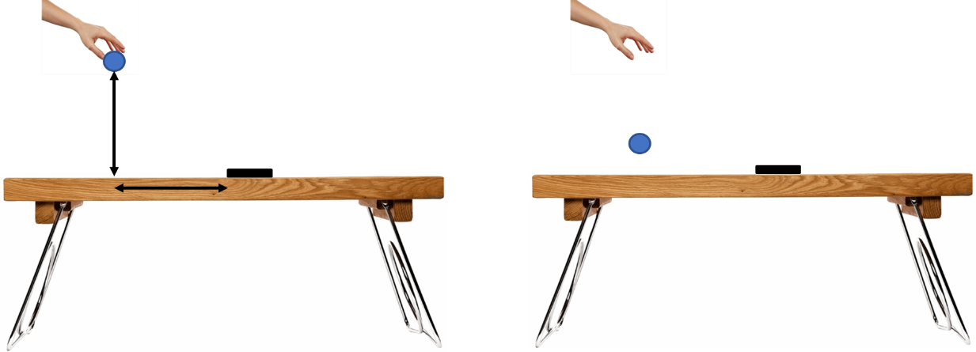

- You will be comparing the acceleration measured by your phone with and without an engineering “landing pad” that will be used to reduce the moment transfer to your phone from the impulse produced by of the ball.
- Constraints on the engineering design:
      - A golf ball will be dropped from a height of 30 centimeters above the surface
      - The region for reducing the impact will be limited to a height of 3 centimeters above the surface. Any materials or designs are allowed provided that they do not touch the ball prior to it reaching 3 centimeters above the surface.
      - The landing pad could be a simple pile of sand, a net or any structure engineered to reduce the momentum transfer to the phone.
- The goal is to reduce the acceleration of the phone when using an engineered “landing pad” in comparison to the initial result with the ball colliding directly with the surface without any engineering modifications. Measure the reduction in acceleration for different designs using the following relationship.

- Explore a variety of designs to see how different approaches impact momentum transfer. Create a table that includes a short description of at least three of your designs and the performance metric achieved for each design. Include multiple trials to confirm reproducibility of your designs.

Analysis and Discussion:

- Describe the designs for each of your experiments and explain the physics involved in reducing the momentum transfer for each design. Include a picture or figure for each.
- Design #1

- Design #2

- Design #3

- What did you determine was the most important engineering concept for reducing the momentum transfer?

- What was the most unexpected result that you observed as you explored different engineering designs?

- Using what you learned from your experiments, describe a design that you would implement if you had no limitations on time or materials that still fits within the constrains.

Extension Question:
- Consider a sky diver jumping out of an airplane without a parachute that reaches a terminal velocity of 200 km/hr. What is the lowest height above the ground you would need to start applying a force to their bodies if they do not want to experience an acceleration greater than 3g?
