Exploring Magnetic Fields: Activity 7
Magnetic Storage: Encoding and Reading Binary Data

Name:______________________ Date:____________ Period:_____

Hypothesis: The magnetometer on a phone can be used to demonstrate the principles of magnetic storage by detecting the direction of magnetic poles encoded in ferromagnetic materials.

Guiding Questions:
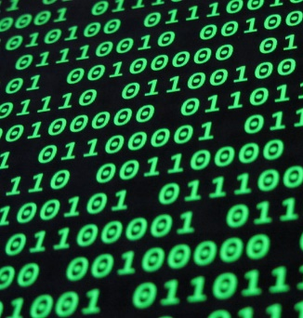
Introduction: Much of the data we use in our daily lives is stored and transmitted using binary numbers, represented by 0’s and 1’s. Localized magnetic dipoles (north and south poles) in ferromagnetic materials provide an ideal platform for storing vast amounts of information. This technology is the dominate method used for long-term data storage. In this activity, you will encode information in a ferromagnetic material using a permanent magnet and then read out the information using the magnetometer in your phone.
If you are not familiar with the binary number system, watch the following video. The video provides very basic principles that are critically important for understanding number systems and the utility of binary numbers. https://www.khanacademy.org/math/algebra-home/alg-intro-to-algebra/algebra-alternate-number-bases/v/number-systems-introduction
- Demonstrate your understanding of binary numbers by converting the binary number 10010011 to the corresponding decimal number. Show your work below.

- When a permanent magnet touches an object constructed from a ferromagnetic material, the object becomes magnetic – a temporary magnet. Describe what happens at both the microscopic (magnetic domains) as well the macroscopic (length of object) scale.

- If the north pole of a permanent dipole magnet is touched against the head of a nail, how will the poles orient in the nail? Label the north and south poles of the macroscopic dipole that is induced in the nail.
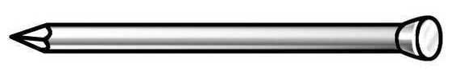
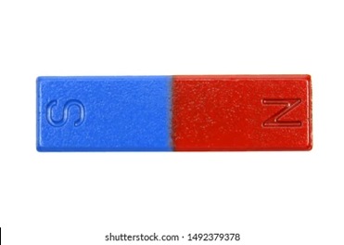

Goals:
- Directly explore how digital information is encoded and read using magnetic properties.
- Enhance students’ understanding and ability to work with the binary number system.
- Engage students in an experimental design activity that is extremely relevant to a current real-world engineering challenge that will remain important for decades to come.
Instructions:
  - Experimentally measure the magnetic dipole orientation that results in a nail following contact with the north or south pole of a permanent magnet. Consider both cases shown below. Include a screenshot of the measurements gathered by a magnetometer as the end of a nail moves toward and then away from the sensor. Gather data for both the head and the point of the nail. Include the geometry (orientation of the nail relative to the phone) for each of the measurements.

  - Use a design similar to the one shown below. In two trials, encode different binary numbers and read them out by scanning the nails past the magnetometer sensor. Include below the graphs of magnetic field vs time for each binary number.
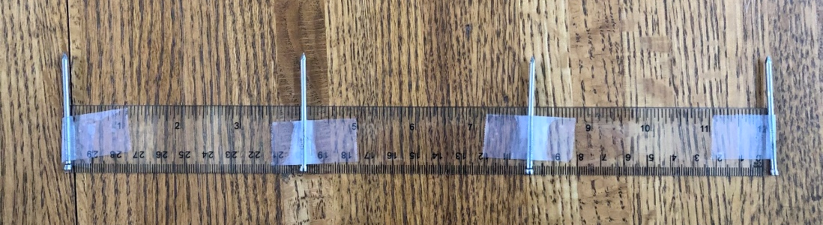

    - Example #1

    - Example #2

  - Using the design above or some variation, encode a number and provide the encoded “digital material” to a classmate to read out. Let them know which end of the string of nails is the least significant digit so they can interpret the data. Include your readout as well as the readout from classmate below (as well as the decimal number that was encoded).

Analysis and Discussion:

- When you touched a permanent magnet to the head of a nail, did it induce changes in the magnetic domains only at the head of the nail or was the tip of the nail also effected?

  - Did you notice if there was a difference in the magnitude of the magnetic field produced by the head of the nail compared to the tip? Repeat the experiment carefully and record the relative magnitudes. What did you observe?

  - How might this property impact the storage of information on magnetic disks or magnetic tape?

- What challenges did you encounter when encoding or reading the sign of the poles associated with each nail? Describe how you addressed these challenges to optimize the performance of your system.

- What challenges did you encounter when you attempted to read out a classmate’s data or when a classmate attempted to read out your data?

  - What changes might you make to improve this information transfer system?

- Estimate the number of nails that you would need to store your favorite song. You will need to do a little research to figure this out. Show your calculations below.

  - Based on the spacing between “bits” used in your current design, how long would your storage device need to be?

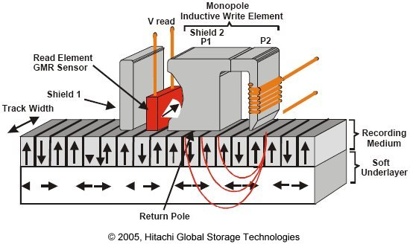
Extension Question:

- Engineers continue to develop technology to store more data in smaller areas and to increase the read and write speeds. A schematic of a device for writing and reading magnetic data is shown to the right. Create an engineering design using the magnetometer in your phone that improves upon storage density and/or read–write speeds compared to the initial method you used in this activity. Provide an illustration or picture of your design and present data to demonstrate the device performance (e.g., video, graphs, …).

