Exploring Magnetic Fields: Activity 5
Exploring the Magnetic Field by Moving Charge in a Straight Conductor

Name:______________________ Date:____________ Period:_____

Hypothesis: The movement of charge in a straight conductor produces a well-defined magnetic field that can be characterized with the magnetometer in a smartphone.

Guiding Questions:
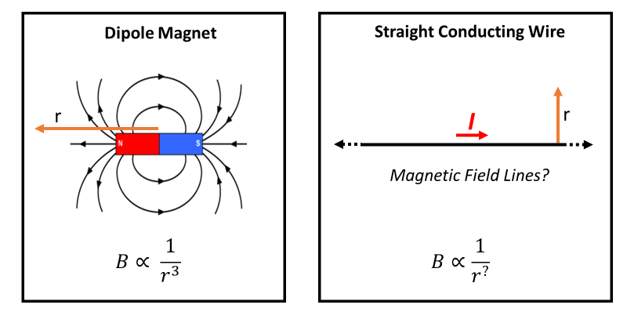
Introduction: In a permanent magnet, the magnetic field lines are defined by the dipole associated with the alignment of magnetic domains in the material. The magnetic field direction and the dependence of the magnetic field strength on distance from the dipole are shown in the figure below. In this activity you will investigate the magnetic fields produced by the macroscopic movement of charge (i.e., current). As is often done when beginning the investigation of a new phenomena, we will start with a simple geometry, a straight conducting wire.

- The magnetic field produced by a current is the foundation of many technologies. Which one of the following does not take advantage of this phenomena?
  - The vibrator in a phone
  - The speakers in earbuds
  - The generation of power at a hydroelectric plant or by a wind turbine
  - A phone charger
  - An electric toothbrush
  - The protection of our atmosphere provided by the Earth’s magnetic field
  - The $140 billion market for electric motors in 2020
  - A pencil (hopefully you get the point – this is a topic of great importance)

- Form a hypothesis on the direction of magnetic field lines around a straight wire conductor. Draw a figure below to illustrate your hypothesis. (It is very unlikely that you would be able to predict this without more information, but it is always useful for scientists to make an initial hypothesis to help design an experiment to test it.)

- Form a hypothesis about the dependence of the magnetic field strength as a function of distance perpendicular from the straight conductor. Explain your answer if you have a scientific basis for your hypothesis.

Goals:
- Characterize the magnetic field surrounding a straight conductor.
- Learn to use the “right hand rule” to determine the direction of the magnetic field produced by current in a straight conductor.
- Build experimental design skills in characterizing three dimensional fields.
- Explore the addition of magnetic field vectors from two different conductors.

Instructions:

  - Design an experiment to characterize the magnetic field around a current carrying straight conductor. Use a battery, a wire, your smartphone magnetometer, and other simple items in the experimental design. Consider the questions below as you design your experiment. You may want to do some quick tests before finalizing an experimental design.
    - How does the magnetic field produced by a single straight conductor compare to the Earth’s magnetic field? Are there orientations relative to the Earth’s magnetic field that might simplify the interpretation of your experimental data?
    - How close will the sensor need to be to the wire to provide sufficient signal to noise for the characterization of the field?
    - Does your configuration allow you to measure the field at multiple locations to determine the 3-dimensional nature of the field?
    - How can you assure that you are measuring the field from the straight section of the wire and no other sections of the wire?
    - Your battery has a limited amount of power that it can deliver. When you connect the positive and negative terminals to form a closed circuit, the delivered current is limited by chemical processes in the battery. Test the stability of the magnetic field when the battery is connected. It is suggested that connections be maintained only for short periods while you make individual measurements (5-10 seconds at a time). You will want to confirm the experimental process is consistent and provides reproducible results.
    - Describe your experimental design below and include diagrams as appropriate.

    - Show selected graphs of the magnetic field vs time that include measurements taken for current traveling in opposite directions in the wire. Include at least one careful quantitative measurement of the field strength at an accurately measured distance from the sensor.

  - Design an experiment to measure the magnetic field strength as a function of distance perpendicular to the conducting wire.
    - Provide a diagram of your experimental design and discuss the various factors considered in designing the experiment.

    - Provide a graph of your data and a table that includes the experimentally measured magnetic field strength at selected distances between the sensor and the straight conductor (when at constant current).

  - Identify an appliance in your house that requires high current (e.g., toaster, hair dryer, large fan, etc.). Monitor the magnetic field around the electrical cord as you turn the device on and off. Capture a screenshot of and plot your data below. Export your data to enable graphing in a spreadsheet in the Analysis and Discussion section.

Analysis and Discussion:

- Based on your measurements of the magnetic field strength near a straight conductor, draw several diagrams depicting the field surrounding the conductor. Your diagrams should include an indication of how the field depends on the direction of the current.

- Graph the magnetic field strength vs distance.

  - Create a graph of the magnetic field strength vs 1/d and include a best fit line.

  - What can you conclude about the relationship between magnetic field and distance?

- It has been shown experimentally that the following relationship describes the magnetic field in a straight conductor.
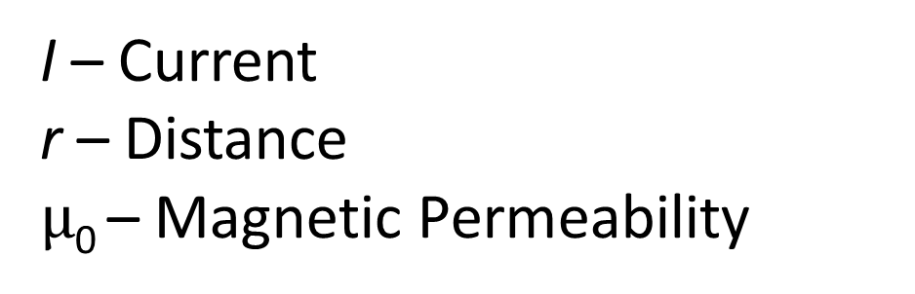
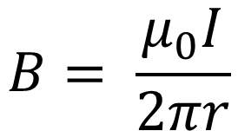

  - In the simple experimental design used in this experiment, the current was not measured directly. What evidence did you have that the current remained constant throughout the experiment?

  - Calculate the current being produced by the battery in your experiment. Compare your measurement with that of other classmates. Did you measure similar values for the current? Provide possible explanations that might account for any differences that were observed.

- Graph the data collected from the appliance power cord using a spreadsheet. Select a section of time that allows you to see individual data points. Use the graphing option that connects the data points in a line so sequential points are more easily visualized.

  - Research the nature of the voltage that is provided to your appliance. Provide an explanation of the magnetic field changes that you observed.

  - When you looked at the graphs of the oscillating magnetic field from the power cord, you might have noticed very interesting patterns. Explain what is causing changes in the pattern? How could this experiment be improved to observe the oscillations?

Extension Question:

- Consider the figure below, which shows an experimental geometry consisting of one long conductor (two wires connected to get the necessary length). When the circuit is completed, the magnetometer on phone 1 measures a magnetic field along the sensors z-axis of -20 μT. The magnetometer on phone 2 measures the magnetic field that results from the wire that is doubled back upon itself. The magnetic field is the vector sum of the two straight conductors with current in opposite directions. Make a hypothesis on what magnetic field strength will be measured by phone 2? Explain your prediction.
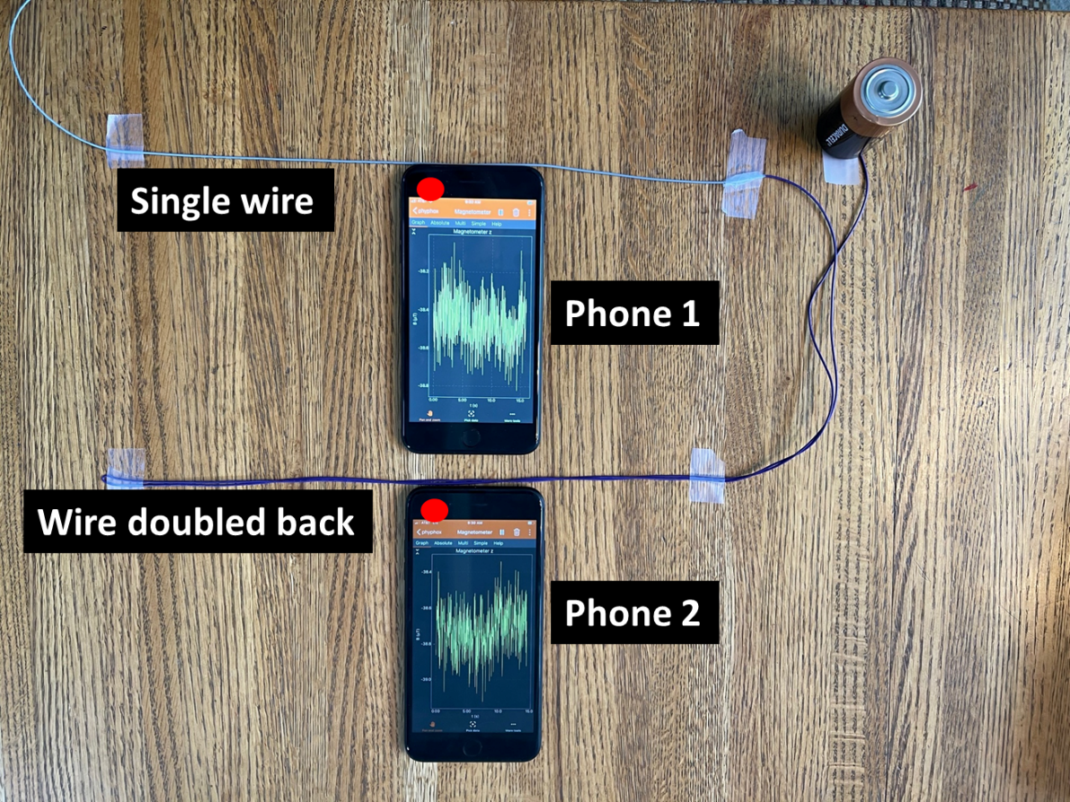

Conduct your own experiment to test your hypothesis. Discuss your observations.

- Have you heard concerns from anyone living near powerlines about the potential health impact of magnetic fields? If you live near powerlines or have the chance to drive under a powerline in your car, you might try to measure any changes in field using your phone magnetometer. Spoiler alert – you will probably not be able to measure any change since your measurements will be dominated by the Earth’s magnetic field and the fluctuations due to orientation of your phone relative to the Earth. However, you might find it interesting to prove this result to yourself.

