Exploring Magnetic Fields: Activity 4
Measuring the Magnetic Field Lines of a Dipole Magnet

Name:______________________ Date:____________ Period:_____

Hypothesis: The 3-dimensional magnetic field surrounding a dipole magnet can be quantitatively mapped using the magnetometer sensor in a smartphone.

Guiding Questions:
Introduction: The ability of magnetic fields to exert force at a distance has revolutionized our technological world. Understanding the magnitude and direction of a magnetic field in three-dimensional space enables scientists and engineers to design an almost endless number of devices that benefit us daily. In this activity you will make quantitative measurements of the magnetic field produced by dipole magnets, providing you with greater understanding and appreciation of the remarkable technologies enabled by magnetic fields.
Magnetic fields can be visualized by drawings which imaginary lines to show the field directions. Magnetic field lines are represented as closed loops that are directed out of the north pole and then loop back into the south pole as show in the figure below. The strength of the magnetic field is represented by the number of lines that pass through a surface (density of lines).
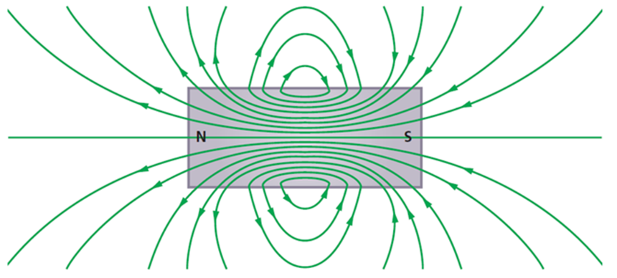

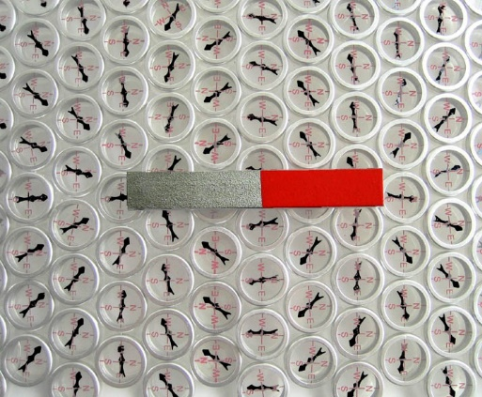
- One approach to measuring the direction of magnetic fields around a dipole magnet is shown in the figure to the right.
  - Based on this measurement, can you determine the direction of the field at any location?

  - Based on this measurement, can you determine the magnitude of the field at any location?

  - How might the Earth’s magnetic field effect the measurement as the distance from the magnet increases?

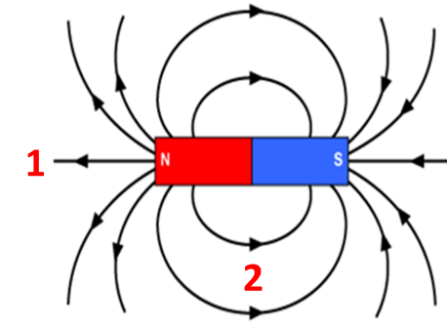
- The magnetometer sensor in your phone provides you with a very powerful measurement tool for studying magnetic fields. Consider measurements at the locations marked in the figure.

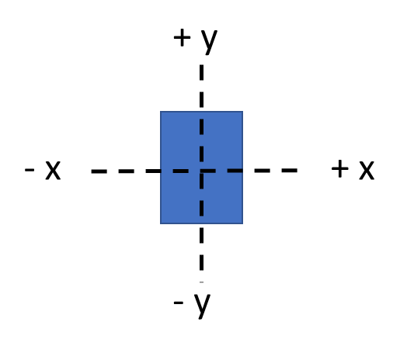
  - If you orient your phone as shown below, with the magnetometer sensor at location 1, what would you expect the magnetic field to be along the three axes? Use the numbers -1, 0 and +1 to indicate the relative magnetic field values.
x-axis: ___________
y-axis: ___________
z-axis: ___________

  - If you orient your phone as shown below, with the magnetometer sensor at location 2, what would you expect the magnetic field to be along the three axes? Use the numbers of -1, 0 and +1 to indicate the relative magnetic field values.
x-axis: ___________
y-axis: ___________
z-axis: ___________

Goals:
- Develop the ability to effectively visualize magnetic fields lines from dipole magnets by quantitatively measuring the magnetic field strength.
- Enhance proficiency in interpreting graphs and connecting observations to 3-dimensional vector fields.
- Build experimental design skills.

Instructions:

  - Use three different experimental configurations to “map” the magnetic field strength along well-defined lines relative to a magnet or a pair of magnets (some potential geometries are shown in the figure below). Adjust the experimental design to ensure that the magnetometer sensor is moving in a plane that contains two axes and is perpendicular to the third axis. (For example, in the box i., the phone is moving in the x-y plane with the z-axis perpendicular to the motion.)
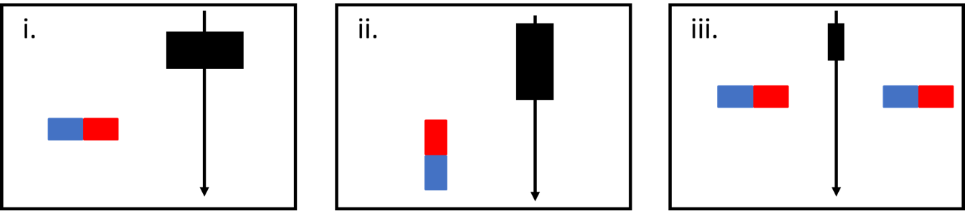

    - Slide the magnet or the phone past the other at a distance of 2-5 cm. The time axis on the graph of magnetic fields will be proportional to the distance moved. While collecting the data, think about how the magnetic fields should change as a function of the phone’s position. This thought exercise may help in adjusting the geometry to ensure the movement is in well-defined planes (it will be difficult to make the experiment perfect, but careful adjustments will help interpretation). Include screenshots of the magnetometer data or plot the data using a spreadsheet for each of the 3 configurations.
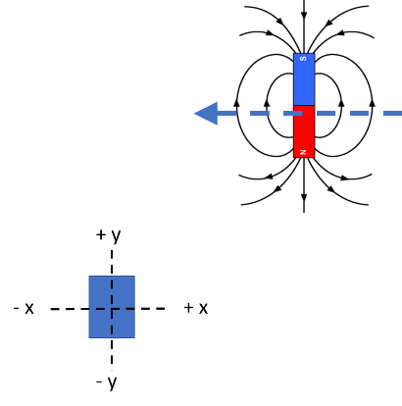
Analysis and Discussion:
- For each of the 3 configurations, draw a diagram showing the geometry of the phone, the position of the magnet along with the magnetic field lines, and the direction of motion. An example diagram is shown on the right. For each configuration, discuss the variation of the magnetic field along the x, y, and z axes that are observed and discuss how well those variations agree with the changes that would be predicted based on the diagram.

Extension Question:

- In the graphs above, the magnetic field strength is plotted as a function of time. Consider how you could design an experiment that would allow you to convert the time to distance. Describe a potential experimental approach. If time allows, test your concept, and produce a graph of magnetic field strength vs distance for one of your configurations.

