Exploring Magnetic Fields: Activity 3
Measuring the Magnetic Field of a Dipole Magnet as a Function of Distance

Name:______________________ Date:____________ Period:_____

Hypothesis: The magnetic field strength of a dipole magnet can be represented as an inverse power law: B = 1/d^{x}.

Guiding Questions:
Introduction: You have identified many different devices that contain magnets and are dependent on the forces that are produced by the associated magnetic fields. The change in magnetic field strength with distance is critical to the design and function of many of these devices. Using the magnetometer sensor in our phones, it is possible to accurately measure the dependence of the magnetic field of a dipole magnet as a function of distance.
- Begin your investigation by taking two magnets and slowly moving the identical poles (e.g., north pole to north pole) toward each other until they come into contact.
  - Describe your general observation.

  - Recognizing that the force you experienced as the magnets approached is proportional to the magnetic field, hypothesize the value of x in the equation below. (Don’t worry about being wrong – this is just an initial hypothesis.)
$$B=\frac{1}{d^{x}}x=?$$

  - Describe what data you might collect and how you would use a graphical method to determine the order (i.e., value of x) of this power law relationship?

Goals:
- Measure the dependence of the magnetic field strength of a dipole magnet as a function of distance.
- Develop skills in designing experiments and testing hypothesis.
- Use graphical methods to determine the order of a power law relationship.

Instructions:
In this experiment you will measure the magnetic field strength of a dipole magnet as a function of distance. There are several experimental design decisions that you will need to make to improve the accuracy of the measurement.

- Determine accurately the distance between the magnet and the sensor.
  - Precise location of the magnetometer sensor
  - Location on the magnet that should be used in measuring the distance from the sensor
- Reduce the impact of stray magnetic fields on the measurement.
- Select sampling distances that will be most useful in conducting the analysis and determining the order of the power law relationship.

  - Distance measurement:
    - Repeat the measurement you did in Activity 1 to precisely locate the magnetometer sensor. Include a drawing below that shows the location of the sensor that includes the distances to the nearest millimeter from two edges of the phone to the magnetometer sensor.

    - If available use two small cube magnets (or any small magnet) as your dipole magnet with the north and south poles identified. Measure the distance to the center of the magnet. Ideally the length of the magnet will be small compared to the distances you will be measuring.

  - Reduce the impact of stray fields:
    - Which of the two cases below might be the best experimental design to minimize the impact of stray fields?

    - Evaluate Case #2 without the magnet present. Do you see a change in the measured magnetic field as you move the phone over 30 centimeters?
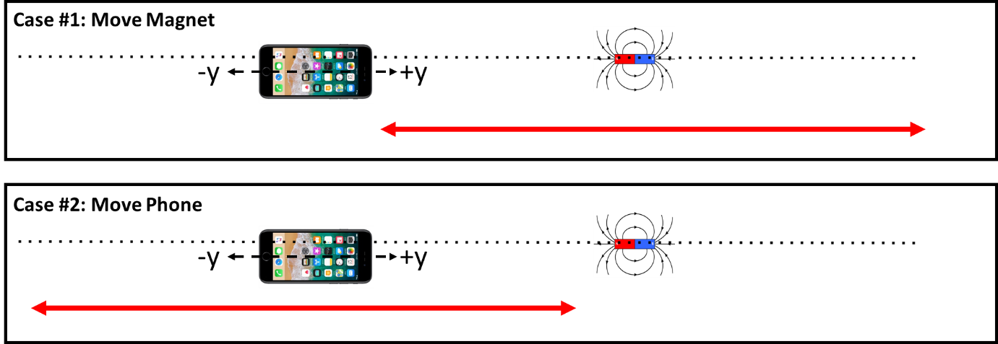

    - Which experiment to you think will provide the best results? Explain.

  - Determination of sampling distances: It is often useful to sample data at intervals that are not linear. Ideally, scientists want to collect data more frequently when small changes in the independent variable (distance) results in a large change in the dependent variable (magnetic field). Oversampling in regions where the independent variable results in very small changes in the dependent variable is not an effective use of the scientist’s time.
    - Explore the change in the magnetic field as a function of distance. Determine:
      - At what distance do I begin to see a measurable change in the magnetic field?
      - At what distances do you begin to see ~2x changes in the magnetic field
      - How close to the magnetometer sensor should you get (a recommendation: not closer than 2 or 3 cm)?

    - Based on this evaluation, determine the distances at which you will sample, which should include approximately 10-12 sampling distances.

  - Make your measurement of the magnetic field vs distance from the dipole magnet.
    - Describe your experimental design and your experimental procedure. Include a diagram. Repeat the collection of measurements at each distance. Include a description of how you determined the value at each distance from your data.

    - Insert a graph of your raw data below. It can be a screen shot or a graph from a spreadsheet.

    - Complete the following data table:
Distance (cm) | Trial #1 Magnetic Field | Trial #2 Magnetic Field

    - Discuss the any significant challenges you had in making the measurements.

Analysis and Discussion:
- Graph magnetic field strength vs distance. Insert graph below.

- Using a spreadsheet, create the following graphs and attempt a linear fit to determine the order of the inverse power law.
  - Magnetic field Intensity vs 1/r
  - Magnetic field intensity vs 1/r²
  - Magnetic field intensity vs 1/r³
  - Magnetic field intensity vs 1/r⁴

- Insert the graph that provides the best linear fit.

- Based on the graphs you created, what can you conclude about the order of the power law relating magnetic field and distance.

$$B=\frac{1}{d^{x}}x=$$

- Do you think this relationship will hold true for magnetic fields that are not produced by a dipole magnet? (We will experimentally explore this in another activity.)

Extension Question:

- The most cost-effective way to store large amounts of digital information is to use magnetic storage devices such as discs or tapes. Individual bits of data are represented by isolated regions of a ferromagnetic material that are either the north or sound pole of induced dipole. A goal of data storage is to get more and more information into a smaller physical space on the surface. If you want to measure a small region on a surface, you will need to get close to it with a very small detector. An example device and a schematic representation of the dipoles on the surface is show in the figure below.
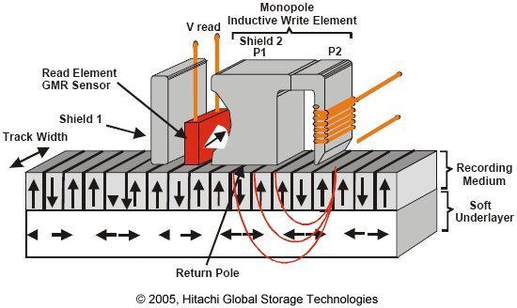

Do you think it would be a technical advantage to have a 1/d dependence or a higher power inverse dependence of the magnetic field as a function of distance? Explain your answer.

