Exploring Magnetic Fields: Activity 1
Identifying Magnets in the World Around You
Name:______________________ Date:____________ Period:_____

Hypothesis: Magnets produce field forces that extend into the surrounding space and are transmitted through many types of materials. The magnetometer sensor in your phone can measure magnetic field strength; therefore enabling the detection at a distance of magnetic materials, which are incorporated into many common items.

Guiding Questions:
Introduction: The principles of electricity and magnetism are foundational to the protection of our atmosphere from charged particles emanating from the Sun as well as the functioning of living systems and many of the engineered devices that we depend upon in our daily lives. You have explored electricity, and in this activity, you will begin to investigate magnetism. As it turns out, electricity and magnetism are inseparable. Magnetic fields are produced whenever there is a moving charge, such as, current in a wire, a charged particle moving through space or electrons moving in an atom (orbiting the nucleus or spinning). In this activity, we will investigate the magnetic properties of materials, begin to explore the many applications of magnets, and learn how to use the magnetometer sensor in our phones to detect magnetic fields.
- You have probably observed that not all materials exhibit observable magnetic properties. Whether a material is magnetic or is attracted by a magnet depends on the details of the electron configuration in the atoms of the material. Materials that either exhibit permanent magnetic properties or can be strongly attracted by permanent magnets are called ferromagnetic materials. Using your previous experience or a quick test with a known magnet, list some examples below.
Magnetic Objects  Contain Ferromagnetic Material | Non-Magnetic Objects

  - Are there patterns in your observations? What types of materials are more likely to appear to be ferromagnetic?

  - Are there exceptions to the trend? Are aluminum cans ferromagnetic?
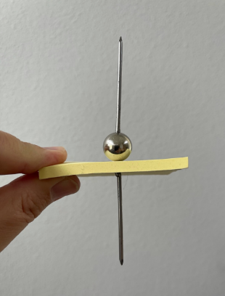
- Consider the picture to the right. The objects in the picture includes two nails, a spherical permanent magnet, and a pad of sticky notes about 5 mm thick.
  - Are the nails ferromagnetic?
  - Is the paper ferromagnetic?
  - The bottom nail appears to be held in place at a distance from the magnetic sphere. What does that suggest about the fundamental properties of a magnetic force?

  - Conduct a similar experiment on your own to demonstrate the ability of a magnetic field to exert force through a non-ferromagnetic material. Briefly describe your experiment and what you observed.

- The influence of a magnet at a distant location can be described by a vector field (magnitude and direction) called the magnetic field (you have already studied gravity and electrical forces that also are non-contact forces described by fields). The SI units used to describe the strength of a magnetic field is the Tesla. A Tesla represents a very strong magnetic field, and you will be measuring fields in the milli- and micro- Tesla range. Of the objects listed in your table in question 1, which do you think produces the largest observable magnetic field?

Goals:
- Introduce magnetism and a few of its basic properties:
  - Magnetic materials produce field forces
  - Only a small number of common materials have readily observable magnetic properties (i.e., are ferromagnetic)
  - Magnetic fields are transmitted through non-ferromagnetic materials with minimal losses in field strength
- Measure magnetic fields using the magnetometer sensor in phones
  - Identify the location of the sensor in the phone
  - The Tesla, T, is the SI unit of measurement for magnetic fields
- Discover the extensive use of magnetics in everyday devices
Instructions:
  - Using the magnetometer: Open the phyphox application on your phone and select the magnetometer sensor. Choose the “Absolute” tab to plot the absolute value (magnitude) of the magnetic field. Move your phone close to a known magnet. Describe your observation.

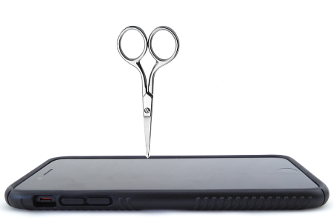
  - Identify the location of your magnetometer sensor: You phone is a large device, and the magnetometer sensor is only a few millimeters in size. Since we know that magnetic field strength decreases rapidly with distance from the source, it is important to determine where the magnetometer sensor is located in your phone as you use it to measure magnetic fields. It is possible to identify the sensor’s location by monitoring the field strength as you scan a pointed object (that is slightly magnetized) over the glass face of your phone. Consider using a pointed object like a nail, tip of a small screwdriver or a pair of scissors. If you have a magnet, touch the magnet to the “tip” of object you will use to ensure it is magnetized. Gently scan the tip over your phone and locate the position of the sensor. Draw a diagram below showing the location of the sensor on your phone (include the type of phone you are using).

  - “Hunt” for magnets: Search your home or classroom for 15 minutes, identifying as many different objects as you can that contain magnets. List the objects below as well as the maximum magnetic field that you measured for each object.

Object | Absolute Magnetic Field (μT)

Analysis and Discussion:
- In which two objects did you detect the largest magnetic field?

  - What do you think the function of the magnets are in the objects?

- Did your measurements provide evidence that magnetic fields penetrate through some non-ferromagnetic materials? Explain.

  - While you know magnetic field can penetrate various materials, you do not know if there is a significant attenuation of the magnetic field strength. Describe an experiment that you could conduct to see if the strength of a magnetic field is altered by the presence of a material barrier.

- Describe two uses of magnets that you did not identify in your classroom or home.

- You may have noted that the absolute value of the magnetic field was not zero even when you did not appear to be close to any magnets. What might be a possible explanation?

Extension Question:

- Using your experimental design from Analysis and Discussion Question #2, conduct an experiment to quantitatively measure the change in the magnetic field that results from interposing your hand. Describe your experiment and your results.

  - Evaluate several other types of materials to see if you are able to find any materials that significantly alter the observed magnetic field. If you are able to find a material that changes the magnetic field, demonstrate that the change you observed was not the result of the material being magnetic and producing its own magnetic field. Show your data and explain your results.

  - What patterns did you observe about materials and their ability to influence magnetic fields?

