Exploring Acceleration: Activity 2
Characterizing “Simple” Movement by Measuring Acceleration

Name:______________________ Date:____________ Period:_____

Hypothesis: If the acceleration of an object is measured using an accelerometer, it is possible to accurately determine both the velocity and the displacement of the object at all points in time if the initial conditions are known.

Guiding Questions:
Introduction: Consider an experiment where you hold your phone close to your body and then extend your arm rapidly before coming to a stop. (See the pictures below.)

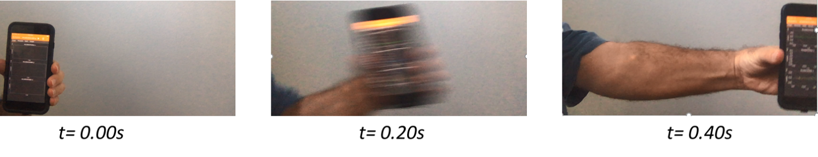

- Draw a motion diagram (series of dots indicating displacement at uniform time intervals) that approximates the motion of the phone in this experiment.

Start End

- The velocity is zero at t = 0.0 s and t = 0.40 s. At what time do you think the velocity is the greatest?
  - 0.10 s b) 0.20 s c) 0.30 s
- At which of the following times to you think the acceleration is closest to zero?
  - 0.10 s b) 0.20 s c) 0.30 s
- At which of the following times to you think the acceleration is positive?
  - 0.10 s b) 0.20 s c) 0.30 s
- At which of the following times to you think the acceleration is negative?
  - 0.10 s b) 0.20 s c) 0.30 s

Goals:
- Explore positive and negative acceleration.
- Use the relationships between acceleration, velocity, and displacement, validate the hypothesis that the velocity and displacement can be accurately calculated from the experimental measurement of acceleration.
Instructions:
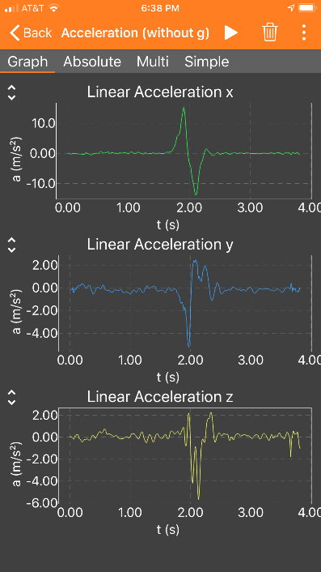
- Conduct the experiment shown in the picture of the “Guiding Questions” section.
  - Collect data using acceleration (without g).
  - Make a quick but smooth motion from your side to an outstretched arm. You can also try starting with an outstretched arm and move the phone toward your body.
  - Attempt to hold the phone in a constant orientation.
  - Attempt to direct the motion along one axis.
  - Conduct several trials and adjust your motion until your data shows you have optimized b-d. An example data set is shown to the right where the motion was directed along the x-axis. As you can see, you will not be able to eliminate acceleration on the other two axes.
  - Export your final data set for analysis in a spreadsheet.

- Graphing and analysis of experimental data (see example worksheet if you need help)
  - Open the spreadsheet with your raw data and create a new sheet.
  - Transfer the time and the acceleration data for the primary axis into the new sheet. (The x-axis data in the case shown.)
  - In order to improve the analysis of your data, it is useful to remove data for times significantly before and after the movement you are interested in analyzing. For example, for the data included here, you would delete data before 1.5 seconds and after 2.5 seconds. You would like to have ~0.2 seconds of data, where the acceleration and velocity are zero, before and after movement.
  - Create a graph of acceleration vs time. Insert the graph below.

  - Calculate the velocity at each point in time from the acceleration and time data. Note the velocity can be calculated using the relationship, Δv = a Δt. You can look in the example spreadsheet to see how to do the calculation if you need help. Create a graph that contains both acceleration and velocity. Insert the graph below.

Maximum velocity from graph: _____________

  - Calculate the displacement at each point in time from the velocity and time data. Note the displacement can be calculated using the relationship Δd = v Δt. Create graph that contains both the velocity and the displacement. Insert the graph below.

Total displacement from graph: _____________
  - Using your displacement data, create a particle-model version of a motion diagram that should looks something like the graph below where each data point represents the displacement at defined time intervals. In the graph below the data points represent 10 ms time intervals.
    - In order to get the graph to look like the one below, we need a set of y values for the program to plot.
    - Using the column next to your total displacement, fill all the cells with ‘0’.
    - Select your displacement column and this new column and graph it.
    - Make sure your displacement is the x-axis and the column of ‘0’s is the series.
    - To make it clearer, you can turn off the vertical axis and label.

Analysis

- Consider the acceleration vs time graph. Explain the changes in sign of the acceleration you observe.

- Consult your graph that contains both acceleration vs time and velocity vs time. What is the acceleration when the phone is moving at maximum velocity? Explain why the velocity reaches a maximum.

- When you calculated the velocity from the acceleration and time data, you were calculating the average velocity over the change in time between two measurements. If your motion was extremely fast relative to your data collection rate, the average velocity might not accurately reflect the “instantaneous” velocity. Do you think this average value of velocity accurately describes the motion and provides a good estimate of the instantaneous velocity? Explain.

- You performed series of calculations on your data to determine the final displacement. How did the displacement you calculated compare to the value you expected from extending your arm? If you did not get the expected value, discuss potential sources of error that might have contributed to the difference.

- How did your predicted motion diagram compare to the experimental motion diagram? Discuss any differences.


Extension Questions:
- Consider the motion on a “drop tower” ride? Sketch graphs for the following:
  - Particle model motion diagram
  - Displacement vs time
  - Velocity vs time
  - Acceleration vs time

